**Name: NEHA ANTONY**

**Roll No:23**

**Batch:MCA-B**

**Date:04-04-2022**

**NETWORKING & SYSTEM ADMINISTRATION LAB**

**Experiment No.: 1**

**Aim**

Familiarization of Hardware Components in a Computer.

**Procedure**

**Motherboard**

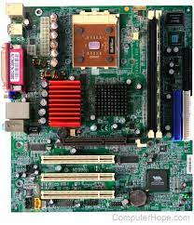

A motherboard provides connectivity between the hardware components of a computer, like the processor (CPU), memory (RAM), hard drive, and video card. There are multiple types of motherboards, designed to fit different types and sizes of computers.

Each type of motherboard is designed to work with specific types of processors and memory, so they don't work with every processor and type of memory. However, hard drives are mostly universal and work with the majority of motherboards, regardless of the type or brand.

**NIC (Network Interface Card)**

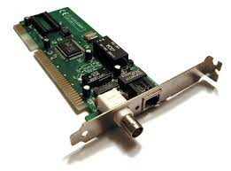

Short for network interface card, the NIC is also referred to as an Ethernet card and network adapter. A NIC is a computer expansion card for connecting to a network (e.g., home network or Internet) using an Ethernet cable with an RJ-45 connector.

**Random Access Memory**

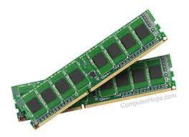

Random access memory (RAM) is fast-access memory that is cleared when the computer is power-down. RAM attaches directly to the motherboard, and is used to store programs that are currently running. RAM is a set of integrated circuits that allow the stored data to be accessed in any order (why it is called random). There are many different types of RAM. Distinctions between these different types include: writable vs. read-only, static vs. dynamic, volatile vs. non-volatile, etc.

**Hard Disk Drive**

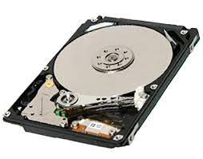 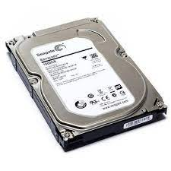 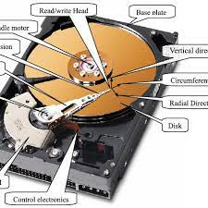

A hard disk drive (HDD) is a non-volatile storage device which stores digitally encoded data on rapidly rotating platters with magnetic surfaces. Just about every new computer comes with a hard disk these days unless it comes with a new solid-state drive. Typical desktop hard disk drives store between 120 and 400GB, rotate at 7,200 rpm, and have a madia transfer rate of 1 Gbit/s or higher. Hard disk drives are accessed over one of a number of bus types, including parallel ATA(also called IDE), Serial ATA (SATA), SCSI, Serial Attached SCSI, and Fibre Channel.

**Processor**

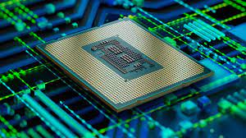 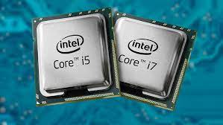

The processor, also called the microprocessor or CPU (for *Central Processing Unit*), is the brain of the PC. It performs all general computing tasks and coordinates tasks done by memory, video, disk storage, and other system components. The CPU is a very complex chip that resides directly on the motherboard of most PCs, but may sometimes reside on a daughtercard that connects to the motherboard via a dedicated specialized slot.

**Heat sink.**

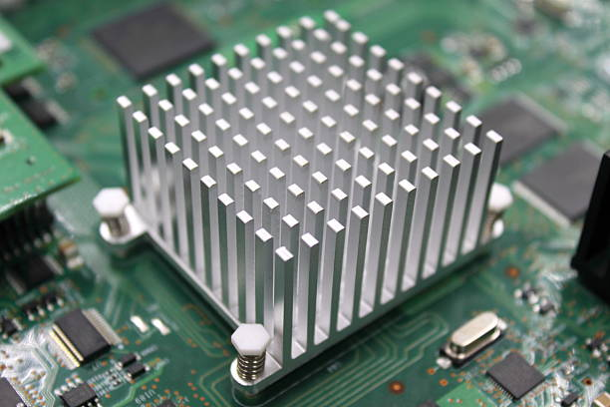 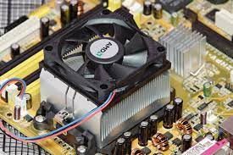

This is a passive piece of hardware that draws heat away from components to regulate/reduce their temperature to help ensure they continue to function properly. Typically, a heat sink is installed directly atop the CPU, which produces the most heat among internal components.

**ROM Memory**

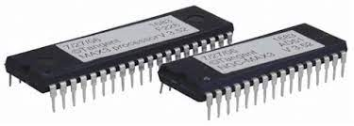 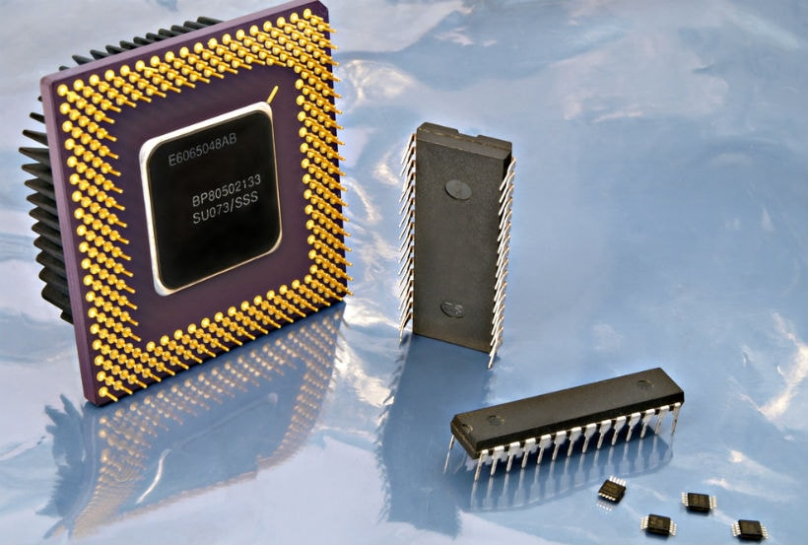

ROM stands for a type of memory chip that can be read from but not written to.

In other words, it's a form of data storage that can't be changed after being programmed.

It's sometimes called "non-volatile" memory because the stored information will remain even when not powered up or in use.

ROM is often used to store a computer's basic start-up instructions and certain types of data, such as your car's onboard computer system and a calculator's data tables.

**Optical Drive**

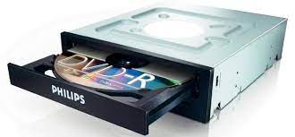 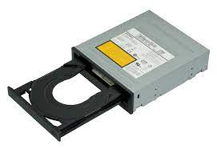

Optical Drives are used in PCs to read and write CDs and DVDs.

The optical drive reads the data from the disc, which can then be transformed into a digital file that is readable by the computer.

This makes it easy to backup files, play music or movies, or copy data from one disc to another.

The term "CD" refers to Compact Discs, which are the most common type of optical drive on modern computers.

**Power Supply**

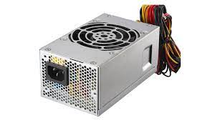 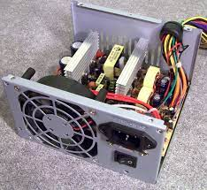

A power supply is an electrical appliance that provides the necessary power to operate a computer.

Computers are powered by electricity, and the power supply converts the alternating current (AC) from the electric outlet into direct current (DC).

The power supply in a computer can be an internal or external component.

It’s important to make sure your power supply is functioning properly.

**Graphics Processing Unit (GPU)**

 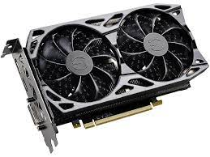

The graphics processing unit, or GPU, has become one of the most important types of computing technology, both for personal and business computing. Designed for parallel processing, the GPU is used in a wide range of applications, including graphics and video rendering. Although they’re best known for their capabilities in gaming, GPUs are becoming more popular for use in creative production and artificial intelligence (AI).

**Solid State Drive (SSD)**

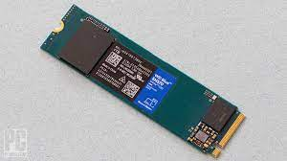 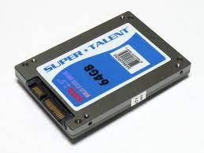

A solid-state drive (SSD) is a new generation of storage device used in computers. SSDs use flash-based memory, which is much faster than a traditional mechanical hard disk. Upgrading to an SSD is one of the best ways to speed up your computer. Learn how SSDs work and how to keep them optimized with a specialized performance-boosting tool.

**Name: Neha Antony**

**Roll No:23**

**Batch: MCA-B**

**Date:21-03-2022**

**NETWORKING & SYSTEM ADMINISTRATION LAB**

**Experiment No.: 2**

**Aim**

Install the latest version of Ubuntu on an Oracle VM VirtualBox.

**Procedure**

Below are the very easy steps with screenshots containing the installation procedure of Virtual Box.

**Output Screenshot**

**Step 1**: [Download VirtualBox](https://www.virtualbox.org/wiki/Downloads) for Windows and install it on the computer.

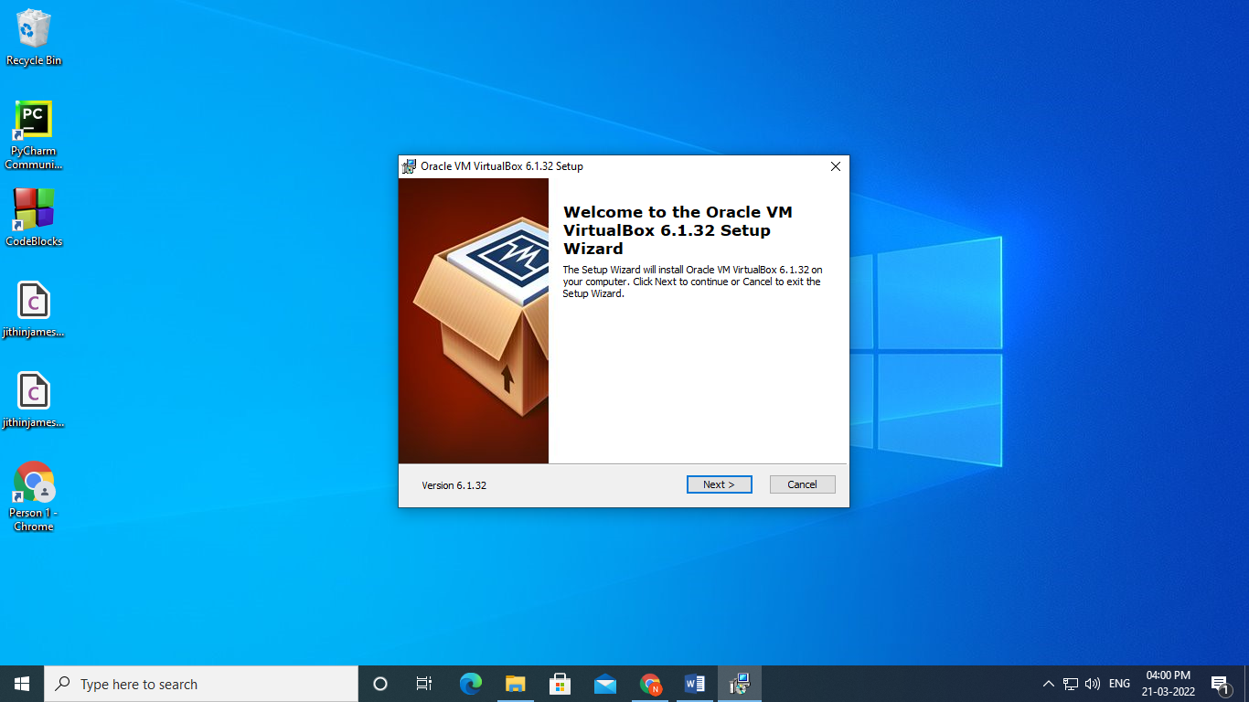

Step 2:clicknext

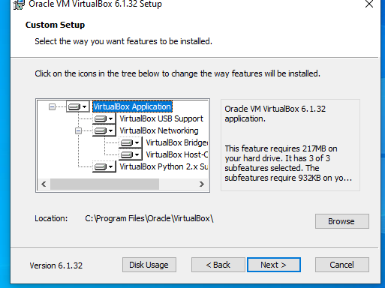

Step 3:click next

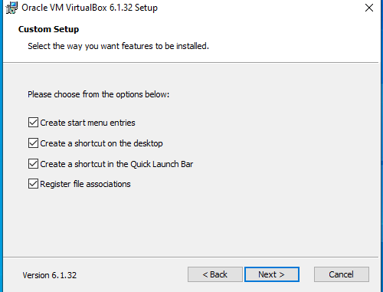

Step4:click yes

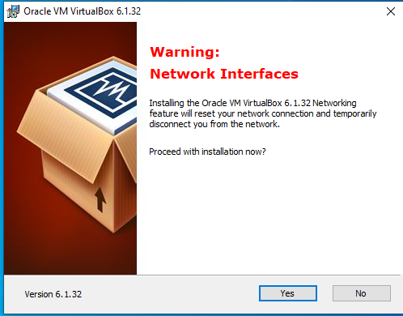

Step 5:click install

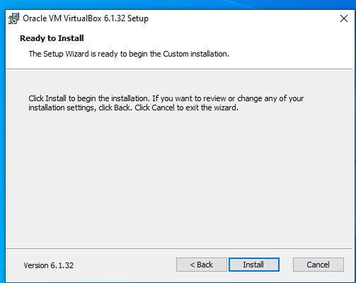

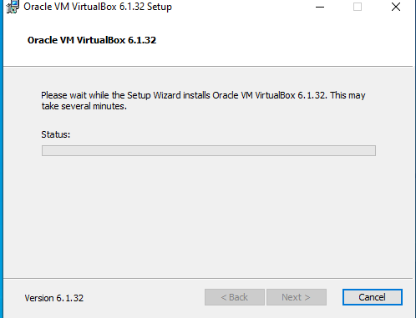

Step 6:install

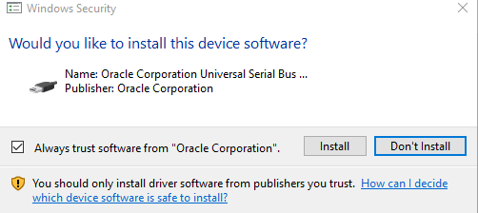

Step 7:finish

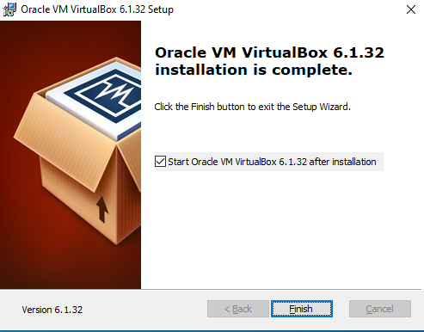

**Step8:** Click on “New” to create a virtual machine

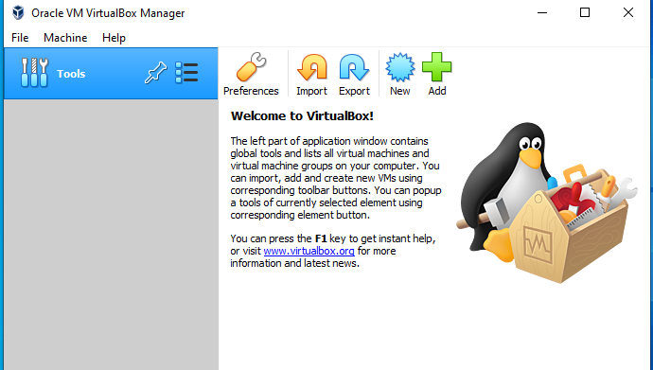

**Step 9:** Enter Name for your Virtual Machine

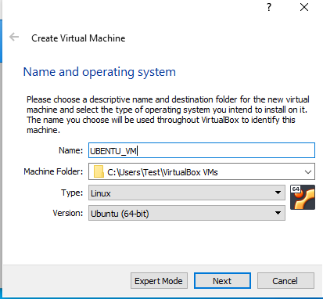

**Step10:** Enter amount of memory (RAM) =1024 MB and click “Next”

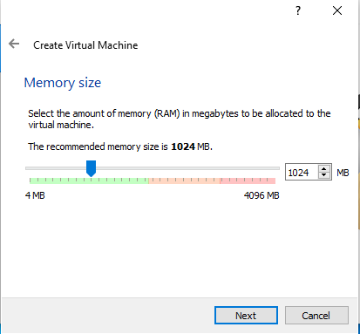

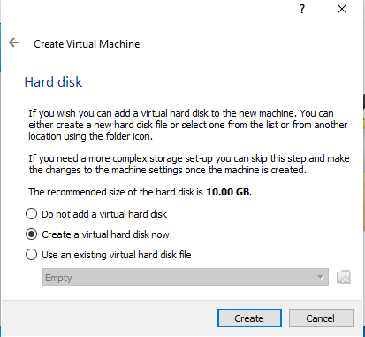

**Step11:** Click “Create” to create hard drive

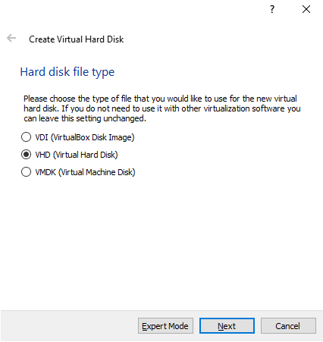

Step 12:click next

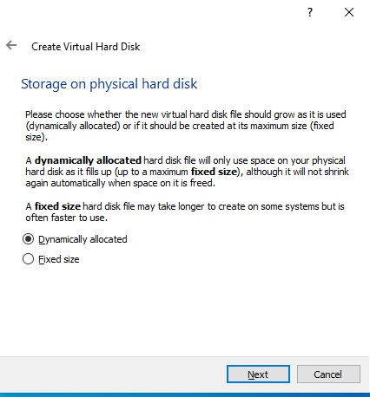

**Step13**: Enter Size of Virtual Hard Drive= 20 GB and Click “Create”

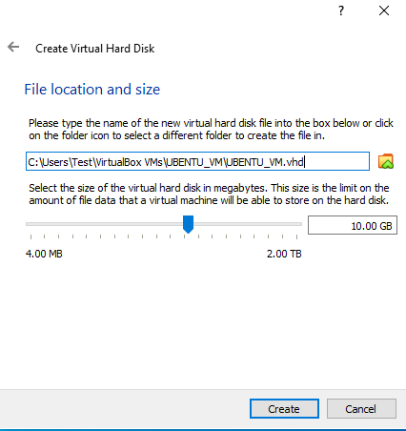

**Step14:** Select Virtual Machine

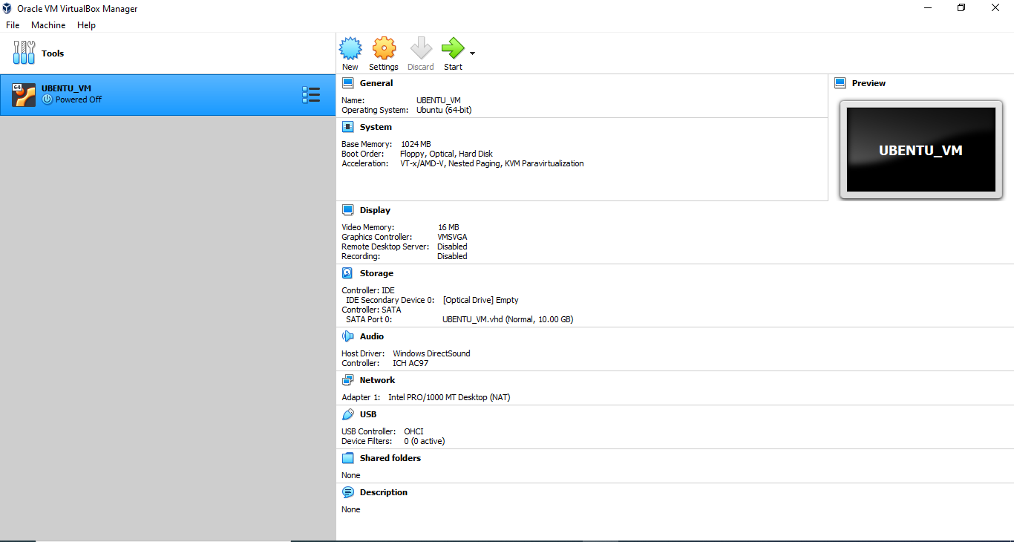

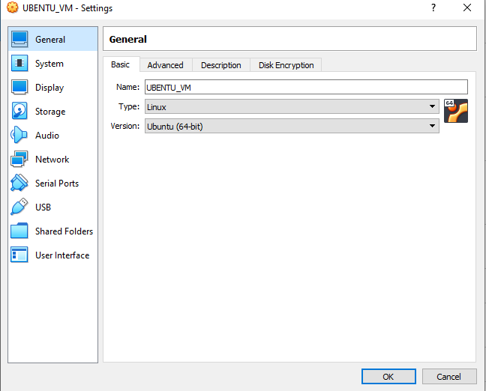

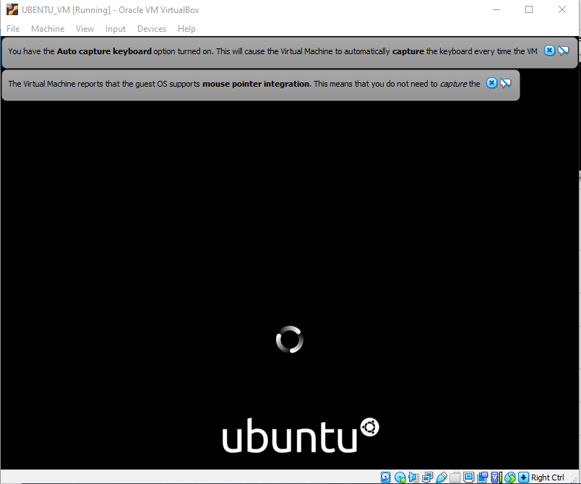

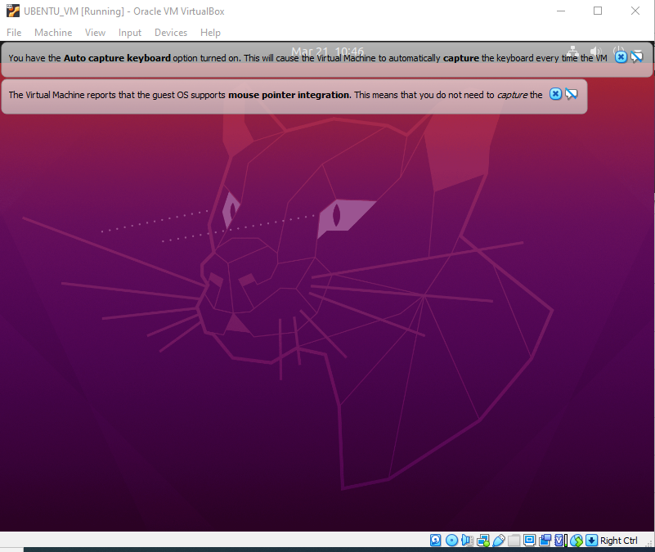

**Step15:** Click “Install Ubuntu”

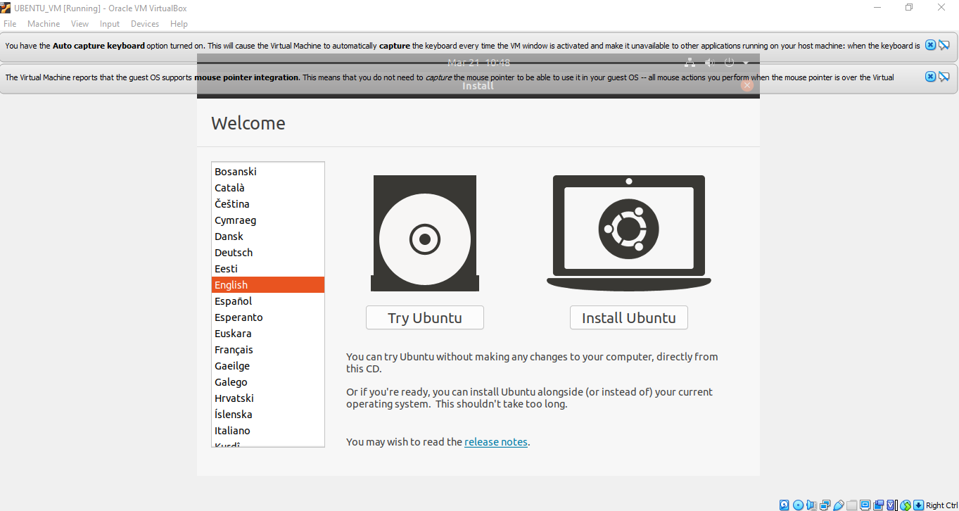

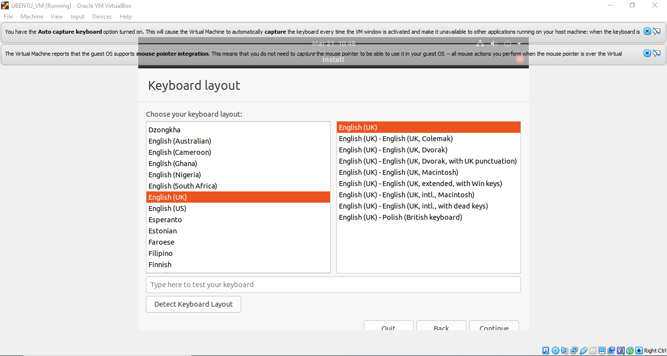

**Step16:** Click “Continue”

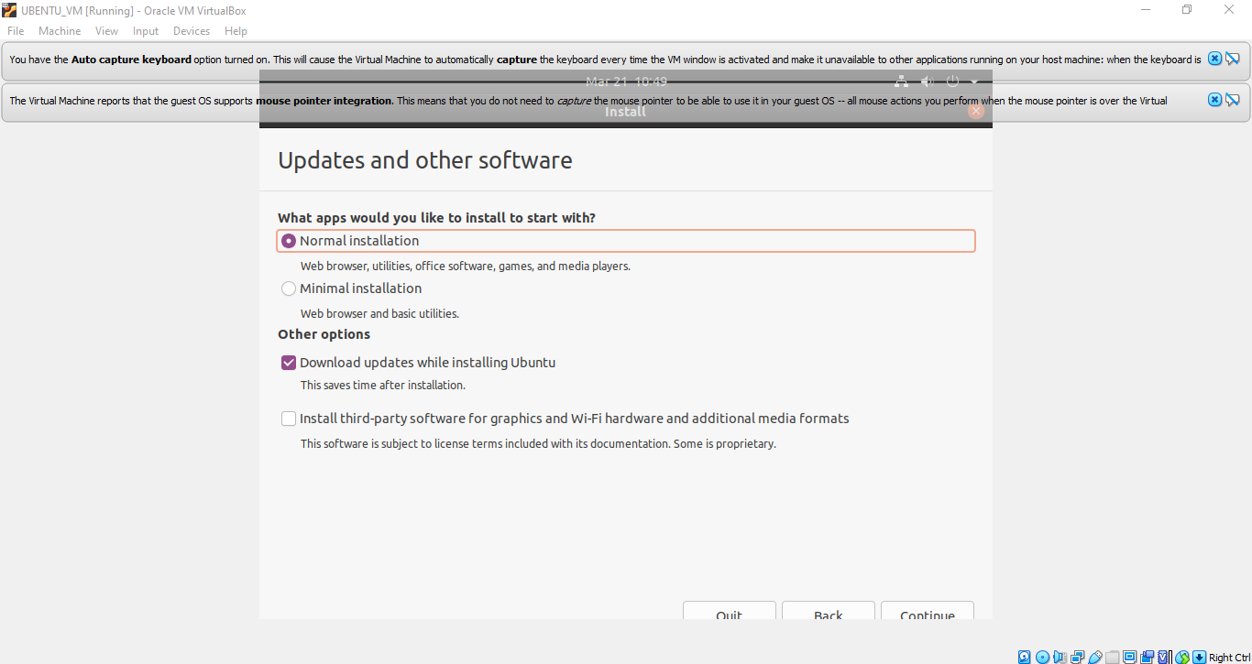

**Step17:** Select location and click “Continue”

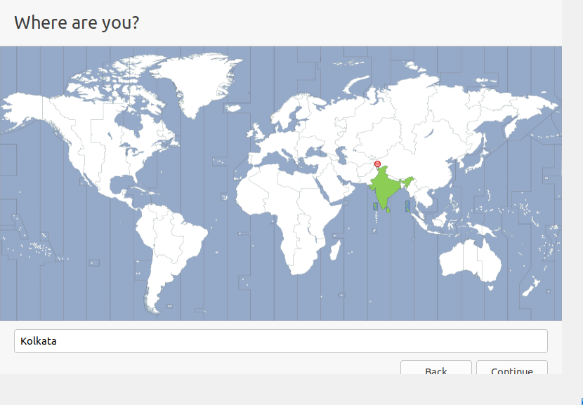

**Step18:** Fill all the details and Click “Continue”

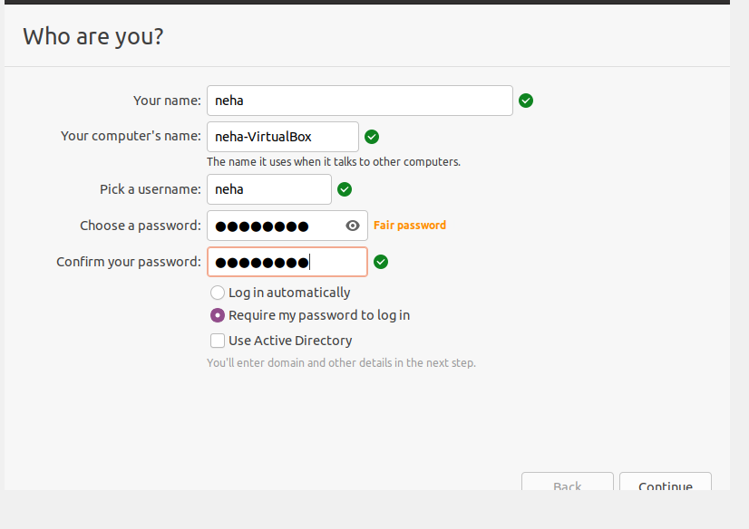

**Step19:**  Now the installation process will start and installation window will appear

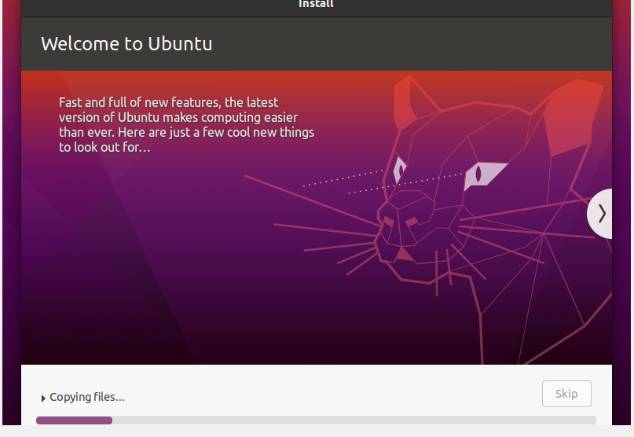

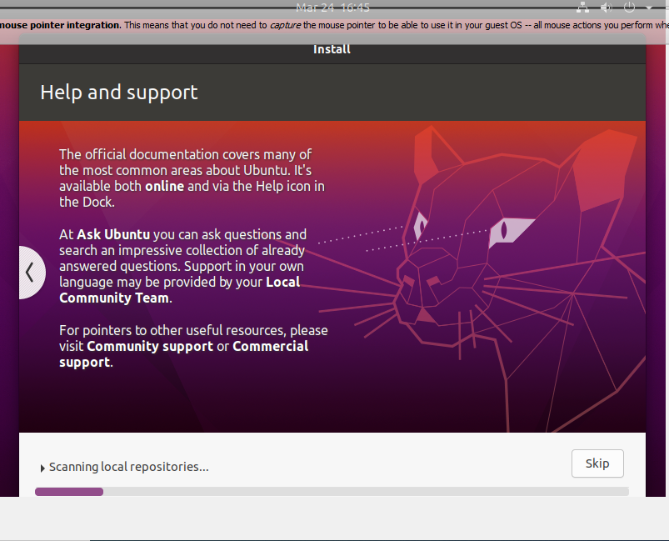

**Step20:**  Click “Restart Now”

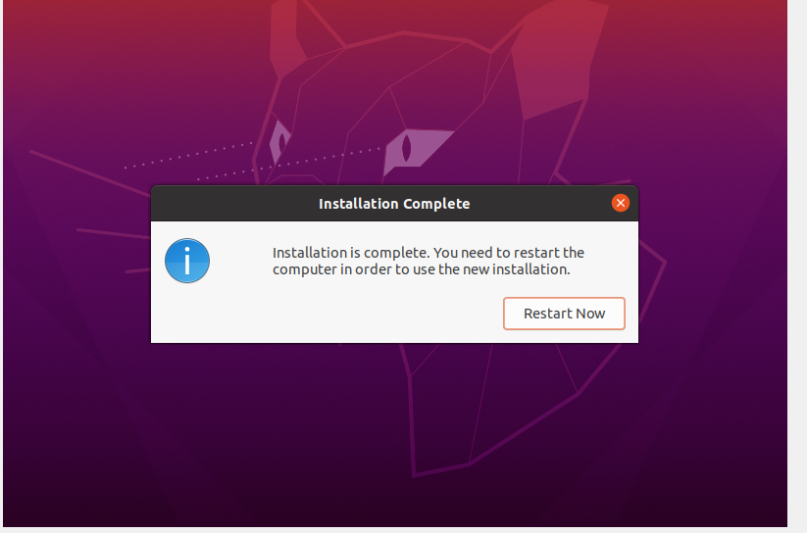

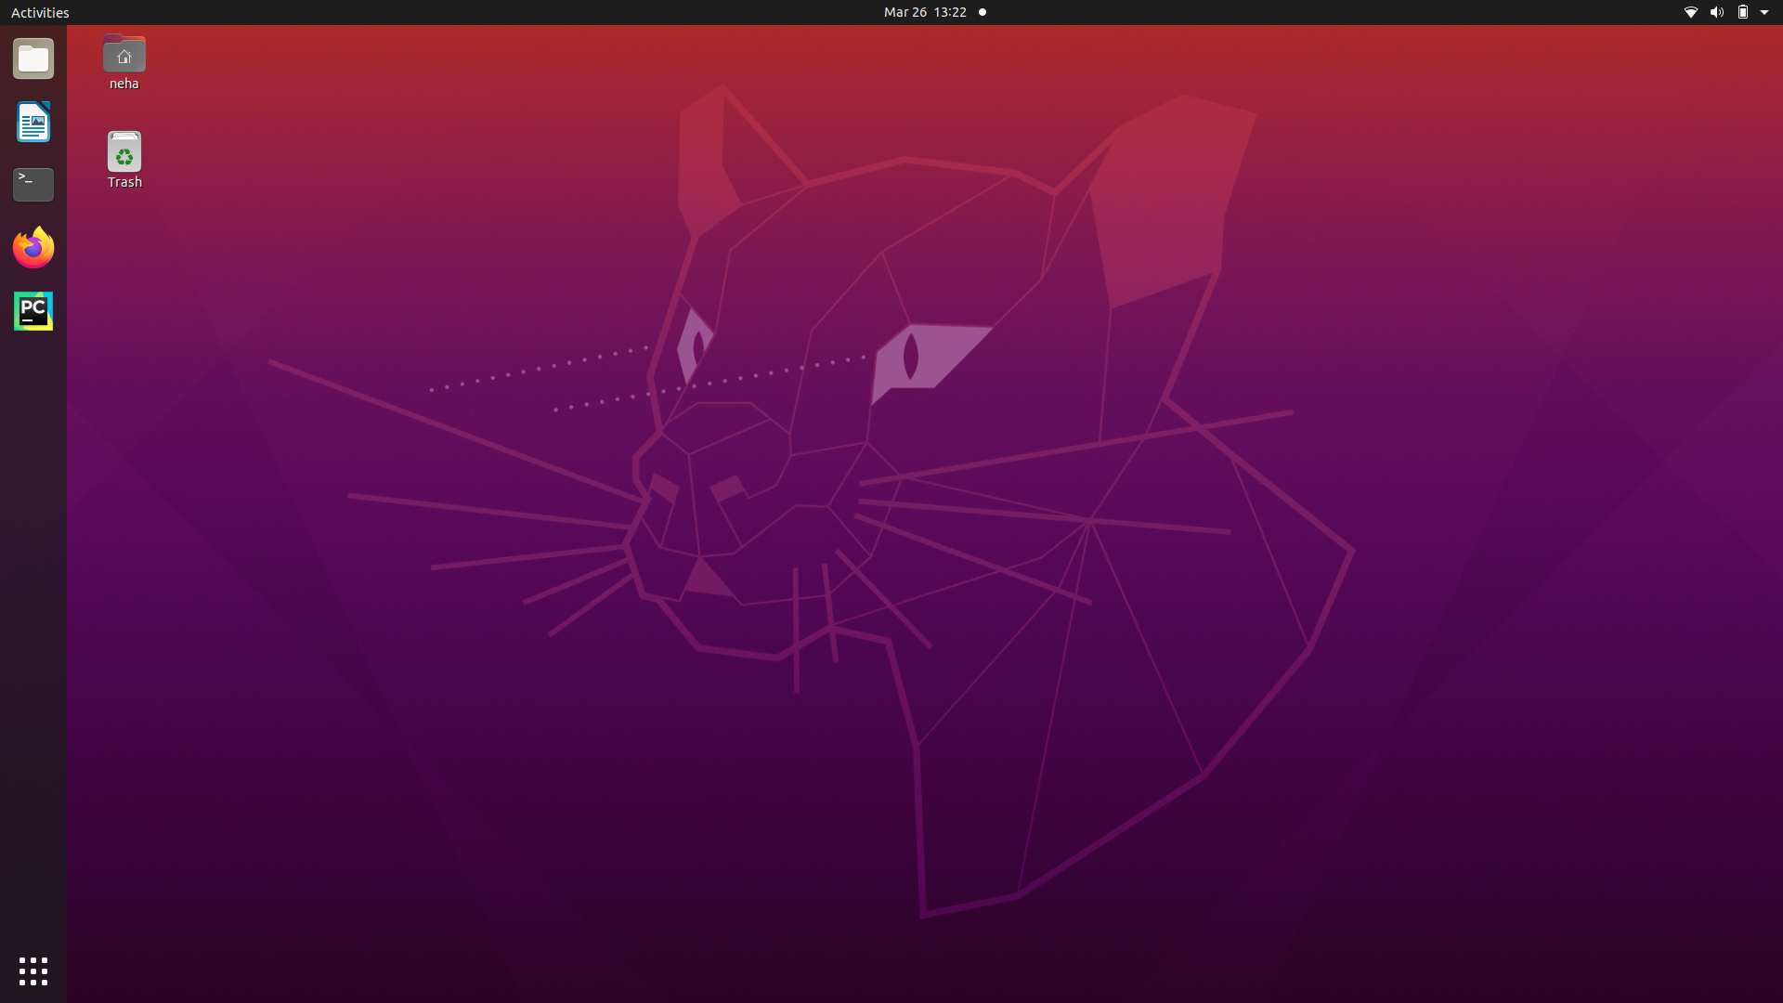

**Name: NEHA ANTONY**

**Roll No: 23**

**Batch:MCA-B**

**Date:24-03-2022**

**NETWORKING & SYSTEM ADMINISTRATION LAB**

**Experiment No.: 3**

**Aim**

Familiarization of the linux commands.

**Procedure**

1. pwd

This command is used to display the location of the current working directory.

Syntax :- $ pwd

Output :-

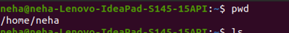

2. mkdir

This command is used to create a new directory under any directory.

Syntax :- $ mkdir <directory name>

Output :-



3. ls

This command is used to display a list of content of directory.

Syntax :- $ ls

Output :-



4. man

This command is used to display the user manual of any command that we can run

on the terminal.

Syntax :- $ man <command name>

Output :-



5. ls –l

This command is used to shows file or directory, size, modified date and time, file

or folder name and owner of the file, and its permission.

Syntax :- $ ls –l

Output:-

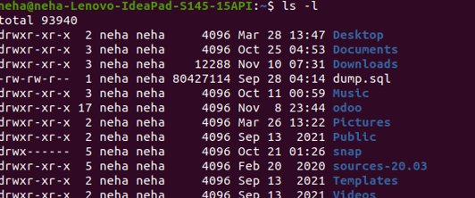

6. ls –r

This command is used to display files and directories in reverse order.

Syntax :- $ls –r

Output :-



7. ls –a

This command is used to list all files including hidden files.

Syntax :- $ls –a

Output :-



8. ls –al

List all the files including hidden files in the current directory

Syntax :- $ ls -al

Output :-

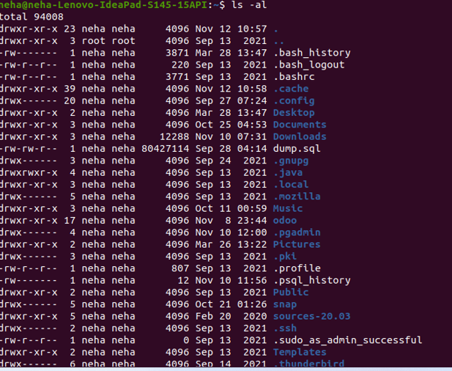

9. ls –t

This command is used to display files in the last modified order.

Syntax :- $ ls –t

Output :-



10. cd

This command is used to change the current directory.

Syntax :- $ cd <directory name>

Output :-



11. cd ..

This command is used to move to the parent directory of current directory, or the

directory one level up from the current directory.

Syntax :- $ cd ..

Output :-  
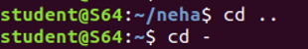

12. cd –

This command is used to switch back to previous directory we were working

earlier.

Syntax :- $ cd –

Output :-

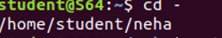

13. cat > filename

This command is used to create a file and add contents to that file.

Syntax :- $ cat > filename.txt

Output :-

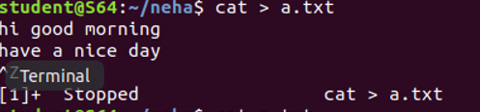

14. cat>>filename

This command is used to add contents to an existing file.

Syntax :- $ cat >> filename.txt

Output :-

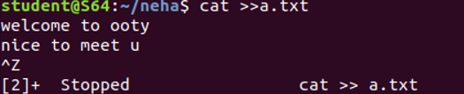

15. cat filename

This command is used to view the contents in the file.

Syntax :- $ cat filename.txt

Output :-

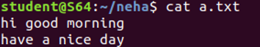

16. cat filename1 > filename2

This command is used to copy the content from one file to another file.

Syntax :- $ cat filename1 > filename2

Output :-



**Name: NEHA ANTONY**

**Roll No: 23**

**Batch:MCA-B**

**Date:28-03-2022**

**NETWORKING & SYSTEM ADMINISTRATION LAB**

**Aim**

Familiarization of the linux commands.

**Procedure**

1. cat -n

Used to display the content of the file with line numbers.

Syntax :- $ cat -n filename.txt

Output :-

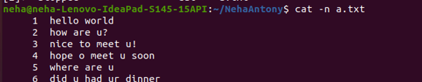

2. cat -b

This command is used to remove empty lines from the file

Syntax :- $ cat -b filename.txt

Output :-

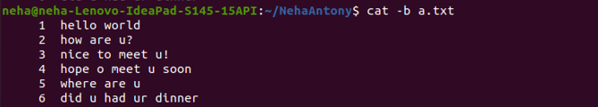

3. touch

The touch command is used to create a file. It can be anything, from an empty txt file to an empty zip file.

Syntax :- $ touch filename.txt

Output :-



4. echo

The "echo" command helps us move some data, usually text into a file. For example, if you want to create a new text file or add to an already made text file, you just need to type in, “echo hello, my name is alok >> new.txt”. You do not need to separate the spaces by using the backward slash here, because we put in two triangular brackets when we finish what we need to write.

Syntax :- $ echo hai dear >> filename.txt

Output :-



5. head

This command is used to display the first N number of lines

Syntax :- $ head filename.txt

Output :-



6. head -4

This command is used to display the first 4 number of lines

Syntax :- $ head -4 filename.txt

Output:-



7. tail

This command is used to display the last N number of lines

Syntax :- $tail filename.txt

Output :-

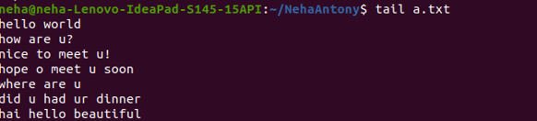

8. cut -d- -f1

**. -f (field):** **-c** option is useful for fixed-length lines. Most unix files doesn’t have fixed-length lines. To extract the useful information you need to cut by fields rather than columns. List of the fields number specified must be separated by comma. *Ranges are not described with -f option*. **cut**uses **tab**as a default field delimiter but can also work with other delimiter by using **-d** option.

Syntax :- $ cut -d- -f1 filename.txt

Output :-

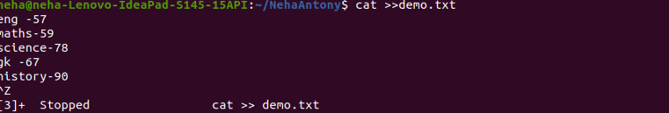

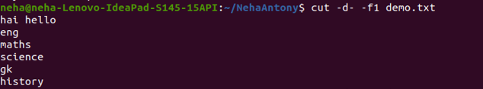

9. cut -d- -f2

This command is used to display files in the last modified order.

Syntax :- $ cut -d- -f2 filename.txt

Output :-

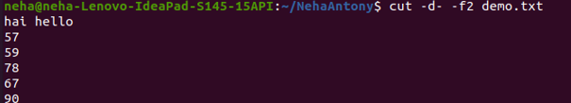

|  |
| --- |
| **Name: NEHA ANTONY**  **Roll No: 23**  **Batch: B**  **Date: 01/04/2022** |

**NETWORKING & SYSTEM ADMINISTRATION LAB**

**Aim**

Familiarization of the linux commands.

**Procedure**

**1 cut -d ‘ ‘**

If -d option is used then it considered space as a field separator or delimiter:

Syntax :- $ cut -d ‘ ‘ f2 filename

Output :-

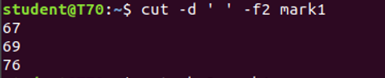

**2. cut -b**

To extract the specific bytes, you need to follow -b option with the list of byte numbers separated by comma. Range of bytes can also be specified using the hyphen(-). It is necessary to specify list of byte numbers otherwise it gives error. **Tabs and backspaces** are treated like as a character of 1 byte.

Syntax :- $ cut -b 2 filename

Output :-

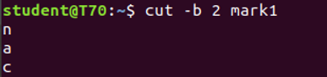

**3. cut –complement**

As the name suggests it complement the output. This option can be used in the combination with other options either with **-f** or with **-c**.

Syntax :- $ cut –complement -c 1 filename

Output :-

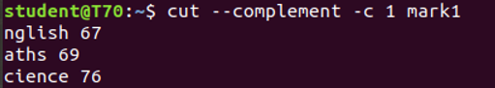

**4. paste**

Paste command is one of the useful commands in Unix or Linux operating system. It is used to join files horizontally (parallel merging) by outputting lines consisting of lines from each file specified, separated by **tab** as delimiter, to the standard output.

Syntax :- $ paste filel file2

Output :-

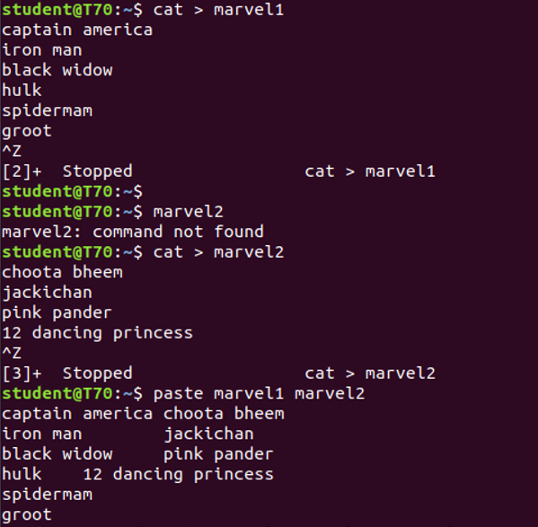

**5. Paste -d (delimiter):**

Paste command uses the tab delimiter by default for merging the files. The delimiter can be changed to any other character by using the **-d** option. If more than one character is specified as delimiter then paste uses it in a circular fashion for each file line separation.

Syntax : $paste -d ‘-‘ file1 file2

Output:-

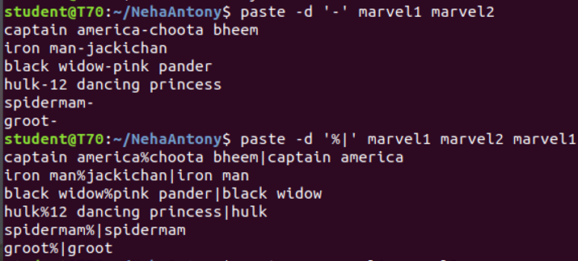

**6.Paste -s (serial):**

 We can merge the files in sequentially manner using the -s option. It reads all the lines from a single file and merges all these lines into a single line with each line separated by tab. And these single lines are separated by newline.

Syntax : $paste -s file1 file2

Output:-



**7. paste file1 file2 > file3**

First and second files are merged into a third file.

Output:-

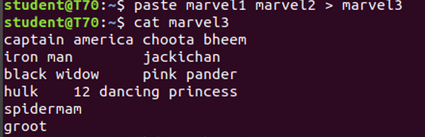

**8. more :**

more command is used to view the text files in the command prompt, displaying one screen at a time in case the file is large (For example log files). The more command also allows the user do scroll up and down through the page.

**SPACE Key** is act as a NEXT button.

**B Key** act as a PREVIOUS button.

**ENTER** **key** is used to view line by line.

Syntax :- $more filename

Output :-

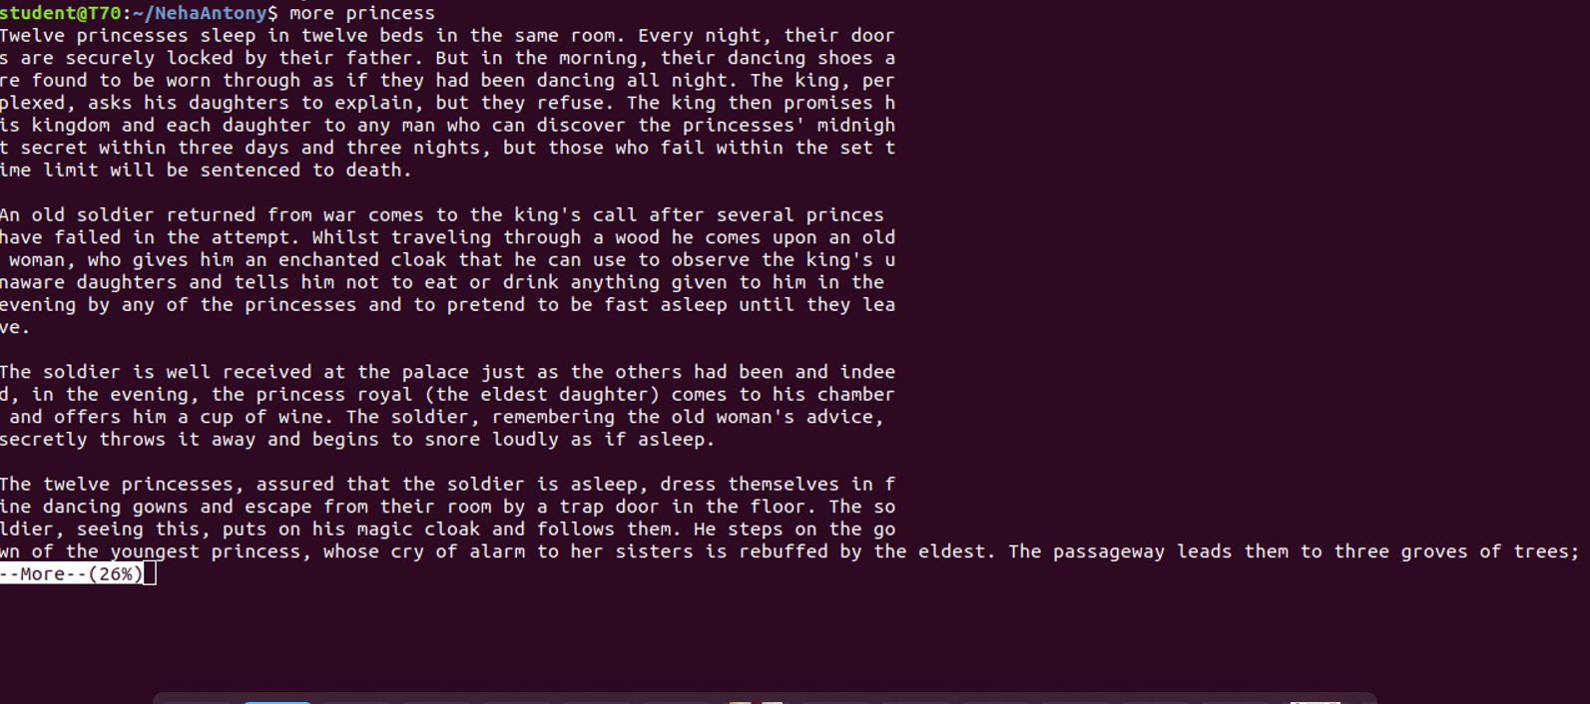

**9. more -s :**

This option squeezes multiple blank lines into one single blank line.

Syntax :- $more -s filename

Output :-

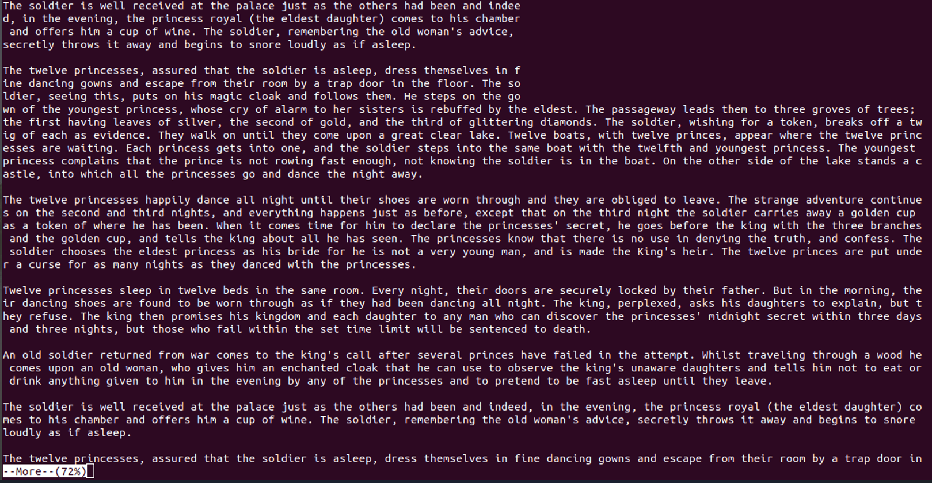

**10. more +n :**

This option displays the text after the specified number of lines of the document.

Syntax :- $ more +n filename

Output :-



**11. more -n :**

type the number of lines that you want to display per screen.

Syntax :- $ more -n filename

Output :-

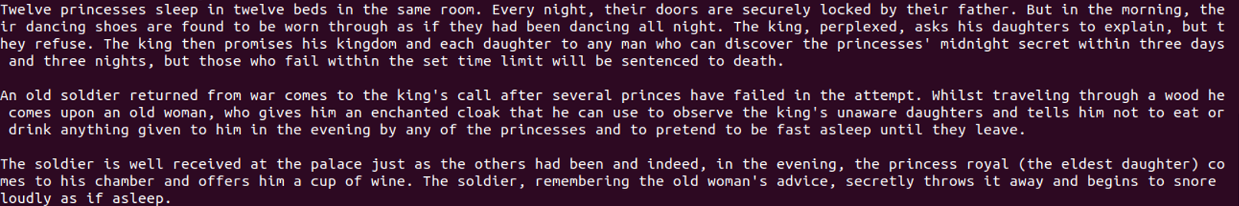

**Name: NEHA ANTONY**

**Roll No:23**

**Batch:MCA-B**

**Date:04-04-2022**

**NETWORKING & SYSTEM ADMINISTRATION LAB**

**Aim**

Familarization of the linux commands

**Procedure**

1. **cp**

cp command is used to copy a file or a directory.

Syntax:

$cp sourcefile destinationfile

Output :

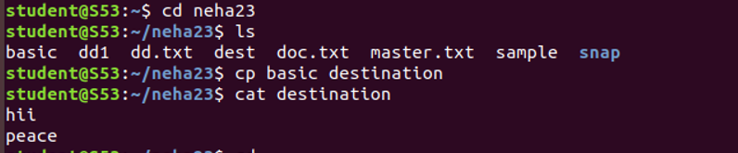

1. **cp –r**

To copy a directory along with its sub dirctories.

Syntax :

$cp -r sourcedirectory destinationdirectory

Output ;

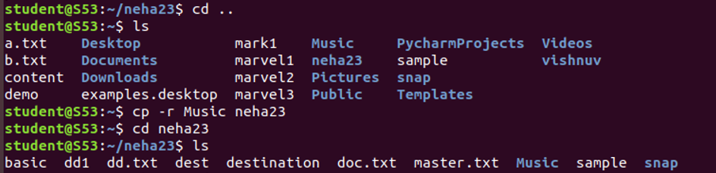

1. **cp -i**

The cp '-i' option allows you to confirm once before overwriting your file.

Syntax :

$cp -i filename directory

Output :

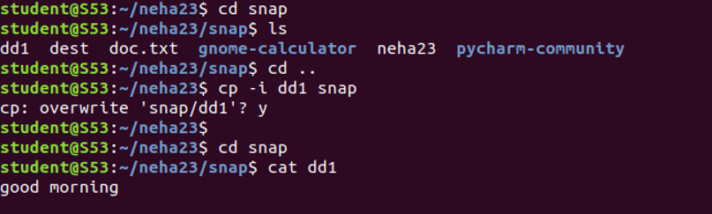

1. mv

**mv** stands for **move**. mv is used to move one or more files or directories from one place to another in a file system like UNIX. It has two distinct functions:   
**(i)** It renames a file or folder.   
**(ii)** It moves a group of files to a different directory.

Syntax :

$ mv sourcefile destinationfile

Output :

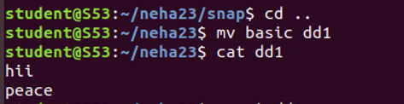

1. mv -i

The -i option makes the command ask the user for confirmation before moving a file that would overwrite an existing file

Syntax :

$mv -i sourcefile destinationdirectory

Output:

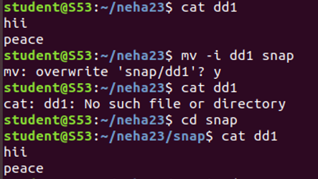

1. mv -f

The -f option overrides this minor protection and overwrites the destination file forcefully and deletes the source file.

Syntax :

$mv -f sourcefile destinationfile

Output ;

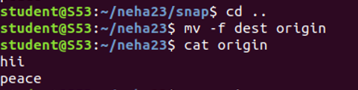

**Name: Neha Antony**

**Roll No:23**

**Batch:MCA -B**

**Date:21-04-2022**

**NETWORKING & SYSTEM ADMINISTRATION LAB**

**Aim**

Familarization of linux commands

**Procedure**

1. **read**

The Linux **read** command is used to read the contents of a line into a variable.

Syntax

$read variable_name

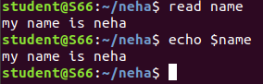

**2. locate**

The locate command and [find](https://www.javatpoint.com/linux-find)command is used to search a file by name. But, the difference between both commands is that locate command is a background process and searches the file in the database whereas, find command searches in the filesystem. The locate command is much faster than find command.

Syntax

$locate filename.txt



**3. locate -i**

It is used to ignore case sensitivity of the specified patterns.

Syntax

$locate -i filename.txt

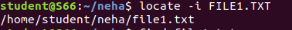

**4 find**

The find command helps us to find a particular file within a directory. It is used to find the list of files for the various conditions like permission, user ownership, modification, date/time, size, and more.

Syntax

$find filename.txt

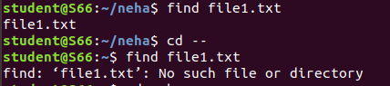

**5.grep**

The 'grep' command stands for **"global regular expression print"**. grep command filters the content of a file which makes our search easy.

Syntax

$grep word filename.txt

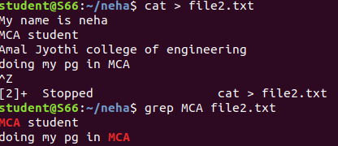

**6. grep -i**

The 'grep -i' command filters output in a case-insensitive way.

Syntax

$grep -i word filename.txt

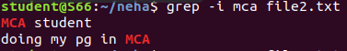

**7 grep -v**

The 'grep -v' command displays lines not matching to the specified word.

Syntax

$grep -v word filename.txt

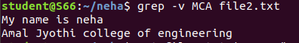

**8. grep -A**

grep -A command is used to display the line after the result.

Syntax

$grep -A word file.txt

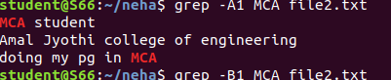

**9. grep -B**

grep -B command is used to display the line before the result.

Syntax

$grep -B word file.txt

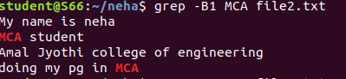

**10.grep -C**

grep -C command is used to display the line after and line before the result.

Syntax

$grep -C word file.txt

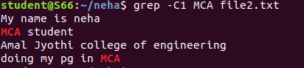

**11. df**

Linux df command is used to display the disk space used in the file system. The 'df' stands for "disk filesystem." It defines the number of blocks used, the number of blocks available, and the directory where the file system is mounted.

Syntax

$du

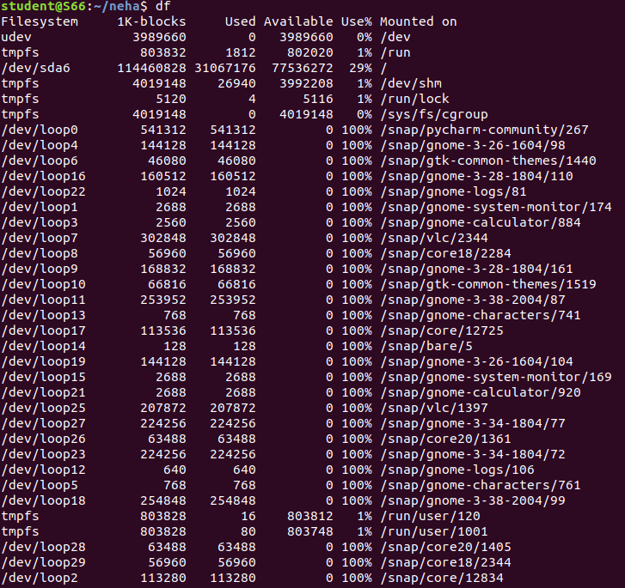

**12. df -m**

it is used to see the report in mega byte

Syntax

$df -m

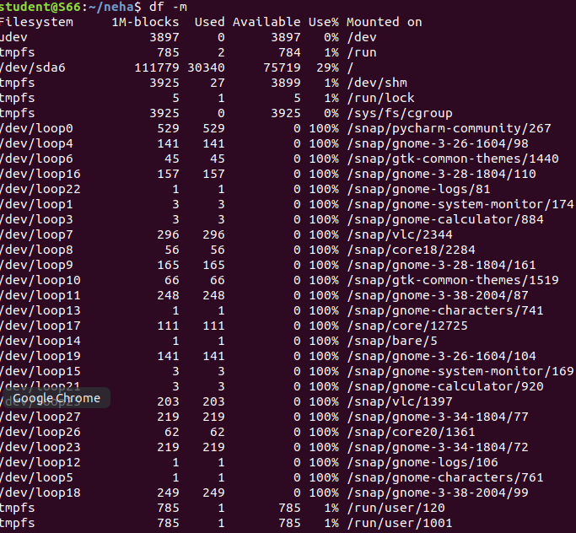

**13. du**

To check how much space a file or directory take.

Syntax

$du

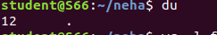

**14.wc**

Linux wc command helps in counting the lines, words, and characters in a file. It displays the number of lines, number of characters, and the number of words in a file. Mostly, it is used with pipes for counting operation.

Syntax

$wc filename.txt

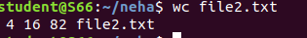

-l, --lines: It is used to print the newline counts.

-w, --words: It is used to print the word counts.

-c, --bytes: It is used to print the byte counts.

-m, --chars: It is used to print the character counts.

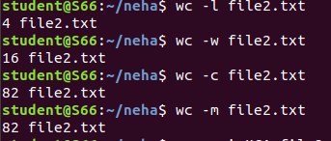

**Name: Neha Antony**

**Roll No:23**

**Batch: MCA -B**

**Date:25-04-2022**

**NETWORKING & SYSTEM ADMINISTRATION LAB**

**Aim**

Familarization of linux commands

**Procedure**

1. **useradd**

useradd is a command in Linux that is used to add user accounts to your system

Output

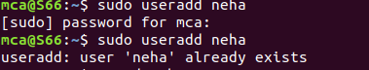

1. **passwd**

passwd command in Linux is used to change the user account passwords. The root user reserves the privilege to change the password for any user on the system, while a normal user can only change the account password for his or her own account.

Syntax:

passwd [options] [username]

Output

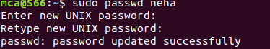

**3. groupadd**

 groupaddcommand is used to create a new user group.

Syntax: 

groupadd [option] group_name

Output

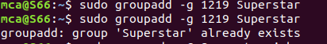

**4.usermod**

usermod command or modify user is a command in Linux that is used to change the properties of a user in Linux through the command line

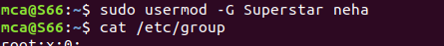Output

**5. compgen**

compgen is a bash built-in command which is used to list all the commands that could be executed in the Linux system. This command could also be used to count the total number of commands present in the terminal or even to look for a command with the specific keyword.

Output

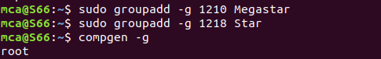

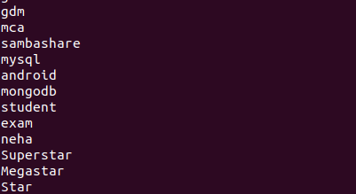

**6. userdel**

userdel command in Linux system is used to delete a user account and related files. This command basically modifies the system account files, deleting all the entries which refer to the username LOGIN. It is a low-level utility for removing the users.

Output

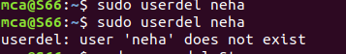

**7.groupdel**

groupdelcommand is used to delete a existing group. It will delete all entry that refers to the group, modifies the system account files, and it is handled by superuser or root user.

Output

**8.chmod**

the chmod command is used to change the access mode of a file.  
The name is an abbreviation of change mode.

Output

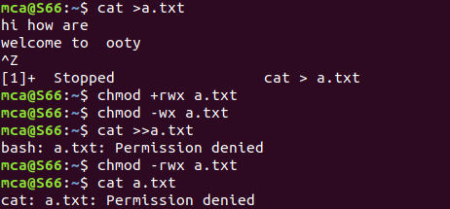

**9 chown**

chown command is used to change the file Owner or group. Whenever you want to change ownership you can use chown command.

Output



**Name: Neha Antony**

**Roll No:23**

**Batch:MCA -B**

**Date:05-05-2022**

**NETWORKING & SYSTEM ADMINISTRATION LAB**

**Experiment No.: 4**

**Aim**

Shell scripting: study bash syntax, environment variables, variables, control constructs such as if, forand while, aliases and functions, accessing command line arguments passed to shell scripts. Study ofstartup scripts, login and logout scripts, familiarity with systemd and system 5 init scripts is expected.

**Question**

Shell program to print a value

**Procedure**

#!/bin/bash

# This is my first shell

echo "Hello World"

**Output**

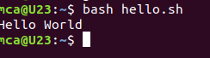

**Name: Neha Antony**

**Roll No:23**

**Batch:MCA -B**

**Date:05-05-2022**

**NETWORKING & SYSTEM ADMINISTRATION LAB**

**Question**

Shell program to add 2 numbers

**Procedure**

#!/bin/bash

echo "enter the value 1"

read a

echo "enter the value 2"

read b

d=$(($a + $b))

echo "sum="$d

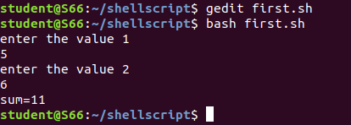**Output**

**Name: Neha Antony**

**Roll No:23**

**Batch:MCA -B**

**Date:05-05-2022**

**NETWORKING & SYSTEM ADMINISTRATION LAB**

**Question**

Shell program to check largest of 2 numbers

**Procedure**

#!/bin/bash

echo "enter 2 numbers"

read a

read b

echo $a $b

if [ $a -gt $b ]

then

echo "$a is greater"

else

echo "$b is greater"

fi

**Output**

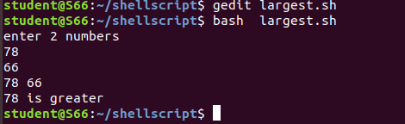

**Name: Neha Antony**

**Roll No:23**

**Batch:MCA -B**

**Date:05-05-2022**

**NETWORKING & SYSTEM ADMINISTRATION LAB**

**Question**

Shell program to check largest of 3 numbers

**Procedure**

#!/bin/bash

echo "enter 3 numbers"

read a

read b

read c

if [ $a -gt $b -a $a -gt $c ]

then

echo "$a is greater"

elif [ $b -gt $a -a $b -gt $c ]

then

echo "$b is greater"

else

echo "$c is greater"

fi

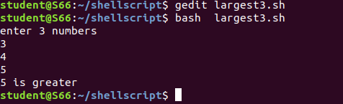**Output**

**Name: Neha Antony**

**Roll No:23**

**Batch:MCA -B**

**Date:05-05-2022**

**NETWORKING & SYSTEM ADMINISTRATION LAB**

**Question**

Shell program to check given number is odd or even

**Procedure**

#!/bin/bash

echo "enter the value"

read a

if [ $(($a % 2)) -eq 0 ]

then

echo "even"

else

echo "odd"

fi

**Output**

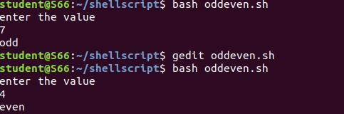

**Name: Neha Antony**

**Roll No:23**

**Batch: MCA -B**

**Date:09-05-2022**

**NETWORKING & SYSTEM ADMINISTRATION LAB**

**Question**

Write a shellscript to display current date and calendar

**Procedure**

#!/bin/bash

echo " Todays date="

echo $(date)

echo "Calender="

cal

**Output**

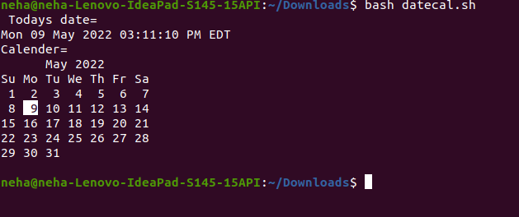

**Name: Neha Antony**

**Roll No:23**

**Batch: MCA -B**

**Date:09-05-2022**

**NETWORKING & SYSTEM ADMINISTRATION LAB**

**Question**

Write a shellscript to check a number is greater than or less than or equal to another number

**Procedure**

#!/bin/bash

echo "enter the two numbers"

read a

read b

if [ $a -gt $b ]

then

echo " $a is greater than $b"

elif [ $a -lt $b ]

then

echo "$a is less than $b"

elif [ $a -eq $b ]

then

echo "$a is equal to $b "

else

echo "invalid"

fi

**Output**

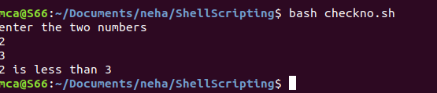

**Name: NEHA ANTONY**

**Roll No:23**

**Batch:MCA-B**

**Date:09-05-2022**

**NETWORKING & SYSTEM ADMINISTRATION LAB**

**Question**

Find the sum of first 10 numbers

**Procedure**

#!/bin/bash

i=1

summ=0

while [ $i -le 10 ]

do

summ=$((summ+i))

i=$((i+1))

done

echo "sum of first 10 numbers = $summ"

**Output Screenshot**



**Name: NEHA ANTONY**

**Roll No:23**

**Batch:MCA-B**

**Date:09-05-2022**

**NETWORKING & SYSTEM ADMINISTRATION LAB**

**Question**

Write a shellscript to find the sum ,average and product of 4 numbers

**Procedure**

#!/bin/bash

echo "enter 4 numbers"

read a

read b

read c

read d

sum1=$((a+b+c+d))

p=`expr $a \* $b \* $c \* $d`

avg=$((sum1/4| bc -l))

echo "Sum=$sum1"

echo "product= $p"

echo "average=$avg"

**Output Screenshot**

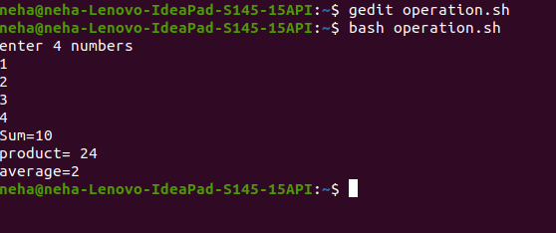

**Name: NEHA ANTONY**

**Roll No:23**

**Batch:MCA-B**

**Date:09-05-2022**

**NETWORKING & SYSTEM ADMINISTRATION LAB**

**Question**

Find the factorial of the given number

**Procedure**

#!/bin/bash

fact=1

echo "enter the number"

read n

for (( i=2 ; i<=n ; i++ ))

do

fact=`expr $fact \* $i`

done

echo "$n != $fact"

**Output Screenshot**

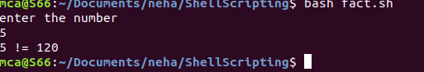

**Name: NEHA ANTONY**

**Roll No:23**

**Batch:MCA-B**

**Date:09-05-2022**

**NETWORKING & SYSTEM ADMINISTRATION LAB**

**Question**

Find the palindrome of a given number

**Procedure**

#!/bin/bash

echo "enter the number"

read n

a=$n

rev=0

while [ $n -gt 0 ]

do

r=$((n%10))

rev=`expr $rev \* 10 + $r`

n=`expr $n / 10 `

done

if [ $a -eq $rev ]

then

echo "palindrome"

else

echo "not palindrome"

fi

**Output Screenshot**

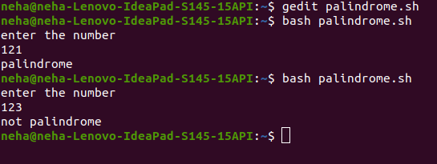

**Name: NEHA ANTONY**

**Roll No:23**

**Batch:MCA-B**

**Date:09-05-2022**

**NETWORKING & SYSTEM ADMINISTRATION LAB**

**Question**

Check whether the given year is leap year or not

**Procedure**

#!/bin/bash

echo "enter the year"

read y

if [ $((y%4)) == 0 ] && [ $((y%100)) != 0 ] || [ $((y%400)) == 0 ]

then

echo "$y is a leap year"

else

echo "$y is not a leap year"

fi

**Output Screenshot**

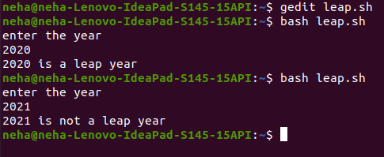

**Name: Neha Antony**

**Roll No:23**

**Batch:MCA-B**

**Date:12-05-2022**

**NETWORKING & SYSTEM ADMINISTRATION LAB**

**Question**

Write a shellscript program to find the sum of all the digits in a number

**Procedure**

#!/bin/bash

echo "Enter the number"

read a

while [ $a -ne 0 ]

do

r=$((a%10))

s=$((s+r))

a=$((a/10))

done

echo "Sum of digit = "$s

**Output Screenshot**

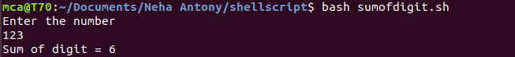

**Name: Neha Antony**

**Roll No:23**

**Batch:MCA-B**

**Date:12-05-2022**

**NETWORKING & SYSTEM ADMINISTRATION LAB**

**Question**

Write a shellscript program to find the sum and average of numbers in command line

**Procedure**

#!/bin/bash

i=0

echo "enter the size"

read n

echo "enter the numbers"

while [ $i -lt $n ]

do

read a

sum=$((sum+a))

avg=$((sum/n))

i=$((i+1))

done

echo "sum=$sum"

echo "average= $avg"

**Output Screenshot**

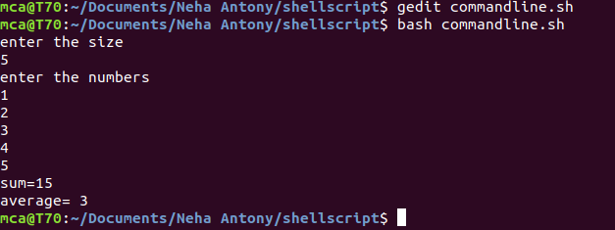

**Name: Neha Antony**

**Roll No:23**

**Batch:MCA-B**

**Date:12-05-2022**

**NETWORKING & SYSTEM ADMINISTRATION LAB**

**Question**

Write a shellscript program to do mathematical calculations using switch case

**Procedure**

#!/bin/bash

echo "enter two number"

read a

read b

echo " 1.Addition "

echo " 2.Substraction "

echo " 3.Multiplication "

echo "4.Division"

echo "5.Exit"

s=1

while [ $s == 1 ]

do

echo "Enter the choice"

read ch

case $ch in

1)

echo "sum= "$((a+b))

;;

2)

echo "Substraction="$((a-b))

;;

3)

echo "Multiplication="$((a*b))

;;

4)

echo "divison="$((a/b))

;;

5)exit

;;

*)

echo "invalid"

;;

esac

done

**Output Screenshot**

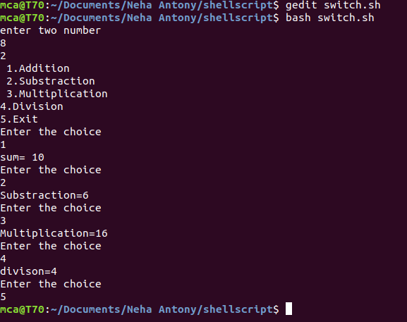

**Name: Neha Antony**

**Roll No:23**

**Batch: MCA -B**

**Date:07-06-2022**

**NETWORKING & SYSTEM ADMINISTRATION LAB**

**Question**

Accessing command line arguments passed to shell

**Procedure**

#!/bin/bash

echo "Average of four numbers="$1 $2 $3 $4

sum=$(($1+$2+$3+$4))

avg=$((sum/4|bc-l))

echo "AVerage=" $avg

**Output**

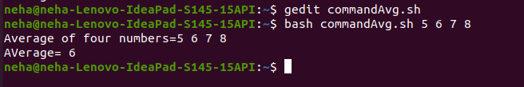

**Name: Neha Antony**

**Roll No:23**

**Batch:MCA-B**

**Date:07-06-2022**

**NETWORKING & SYSTEM ADMINISTRATION LAB**

**Experiment No.: 5**

**Aim**

Installation and configuration of LAMP stack. Deploy an open source application such as phpmyadmin and Wordpress.

**Procedure**

**INSTALLING APACHE**

**Step 1** :Installing Apache and Updating the Firewall

The Apache web server is a popular open source web server that can be used along with PHP to host dynamic websites.

First, make sure your apt cache is updated with:

Syntax: $ sudo apt update

**Output:**

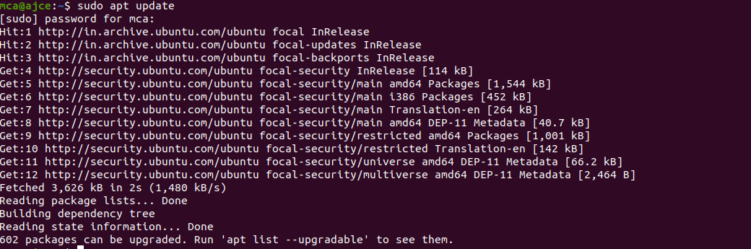

**Step2** :Install Apache 2

Once the cache has been updated, you can install Apache with:

Syntax: $ sudo apt update

Press Y and hit ENTER to confirm, and the installation will proceed.

**Output:**

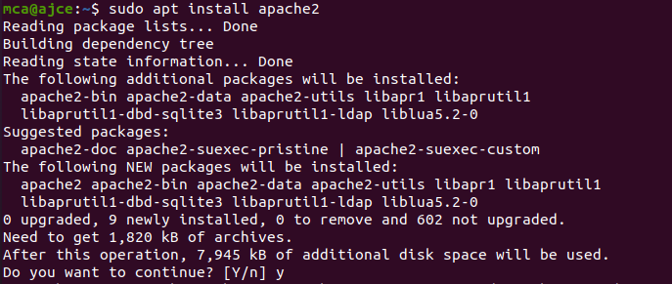

**Step 3** :Adjust the Firewall to Allow Web Traffic

Next, assuming that you have followed the initial server setup instructions and enabled the UFW firewall, make sure that your firewall allows HTTP and HTTPS traffic. You can check that UFW has an application profile for Apache.

**Output:**

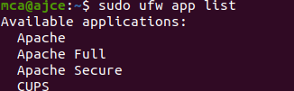

**Step 4** :Check Apache Full

Apache Full profile details, you’ll see that it enables traffic to ports 80 and 443:

Syntax: sudoufw app info "Apache Full"

**Output:**

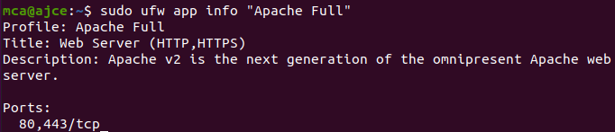

To allow incoming HTTP and HTTPS traffic for this server, run

Syntax: sudoufw allow "Apache Full"

**Output:**

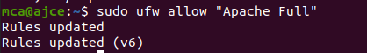

**Step 5**:A spot check right away to verify that everything went as planned by visiting your server’s public IP address in your web browser

**Output:**

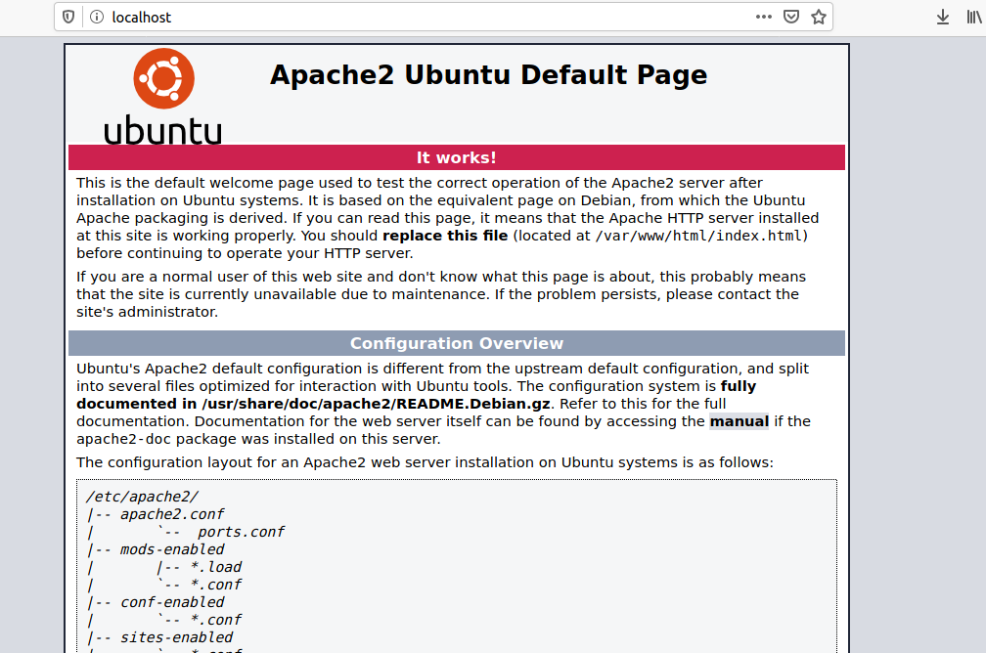

**Installing MySQL**

**Step 1**:In this case, you do not have to run sudo apt update prior to the command. This is because you recently ran it in the commands above to install Apache. The package index on your computer should already be up-to-date.

Syntax: $ sudo apt install mysql-server

**Output:**

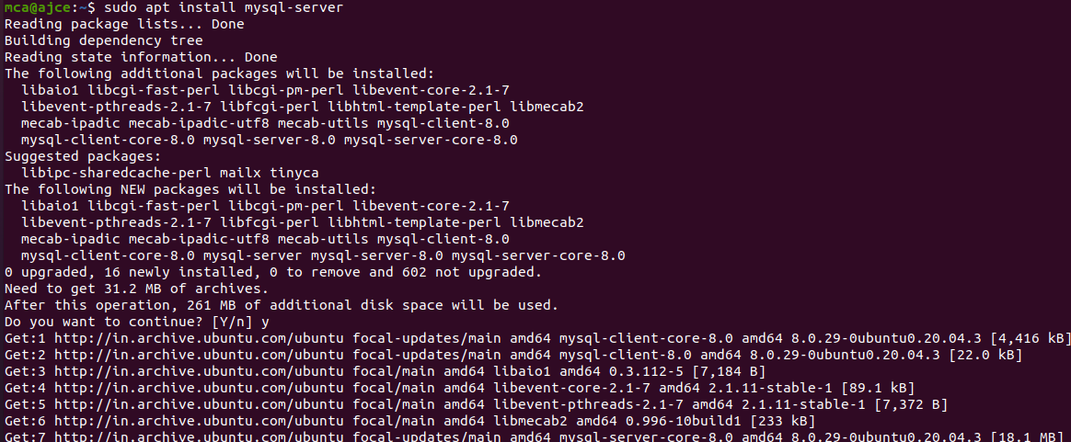

**Step 2** :

This will connect to the MySQL server as the administrative database user root, which is inferred by the use of sudo when running this command.

Syntax: $ sudomysql

**Output:**

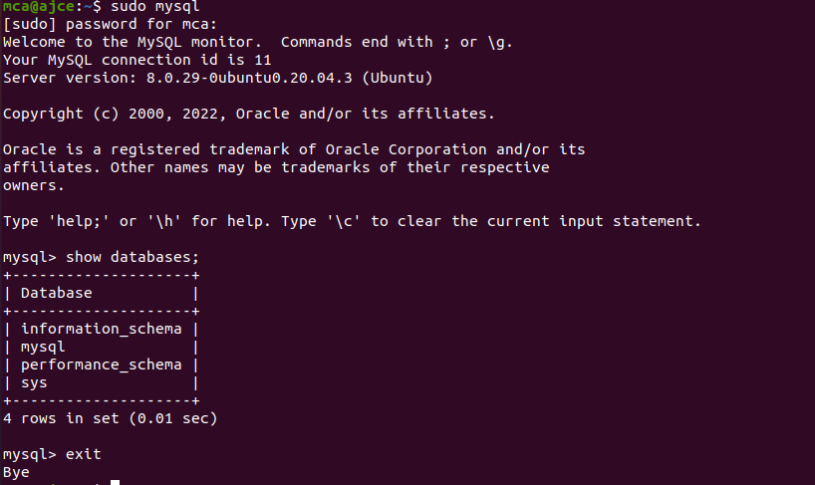

**Installing PHP**

In addition to the php package, you’ll also need libapache2-mod-php to integrate PHP into Apache, and the php-mysql package to allow PHP to connect to MySQL databases. Run the following command to install all three packages and their dependencies.

**Step 1** :Installation

Syntax: sudo apt install php libapache2-mod-php php-mysql

**Output:**

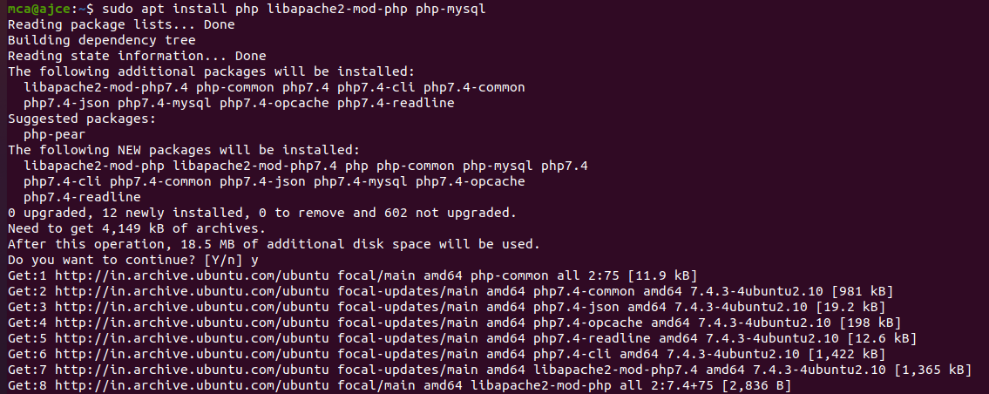

**Step 2** :Restart

Syntax: sudosystemctl restart apache2

**Output:**



**Step 3** :Testing PHP Processing on your Web Server

**Output:**



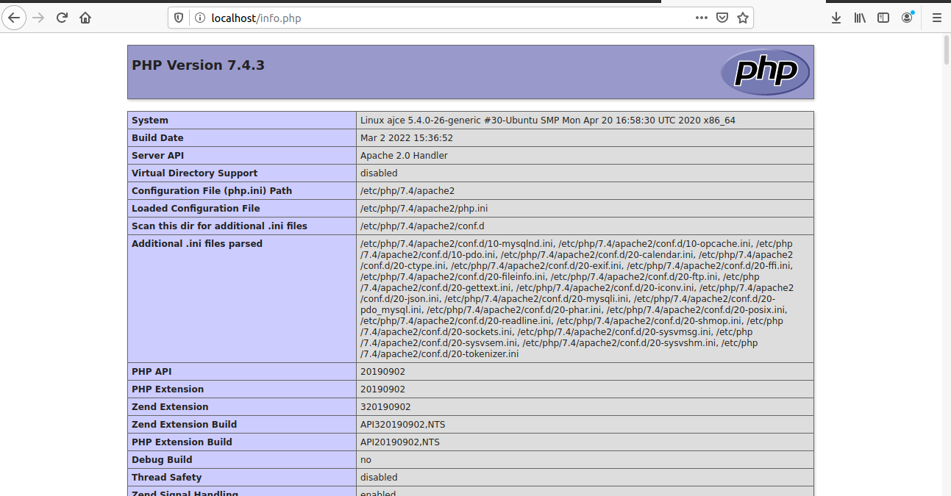

**Install WordPress with LAMP on Ubuntu 18.04**

**Step 1**:Download WordPress

Syntax: $ wget -c http://wordpress.org/latest.tar.gz

$ tar -xzvf latest.tar.gz

**Output:**

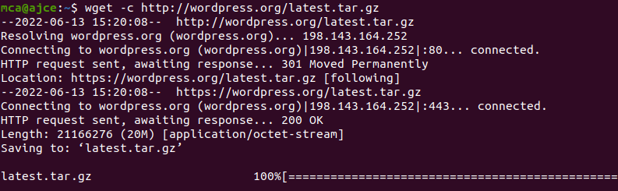

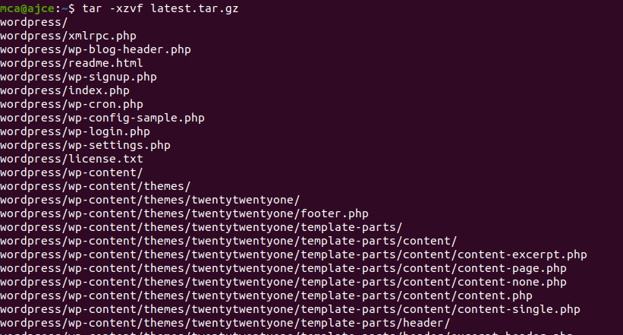

**Step 2** :Creating a MySQL Database and User for WordPress

The first step you’ll take is a preparatory one. Even though MySQL is already installed, you still need to create a database to manage and store the user information for WordPress to use. To get started, log into the MySQL root (administrative) account by issuing the following command:

Syntax: $ sudomysql

You will be prompted for the password you set for the MySQL root account when you installed the software. However, if you have password authentication enabled for your root user, you can run the following command and enter your password information when prompted:

Syntax: $ mysql -u root –p

**Output:**

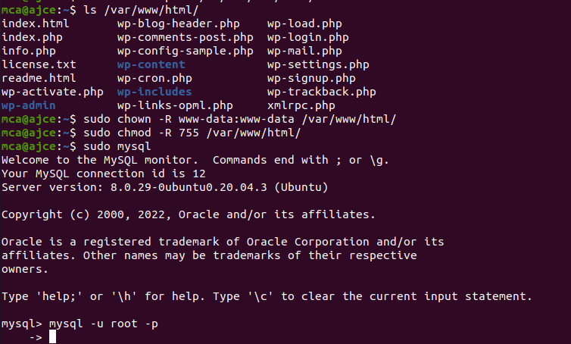

**Step 3** :Create the database for WordPress

**Output:**

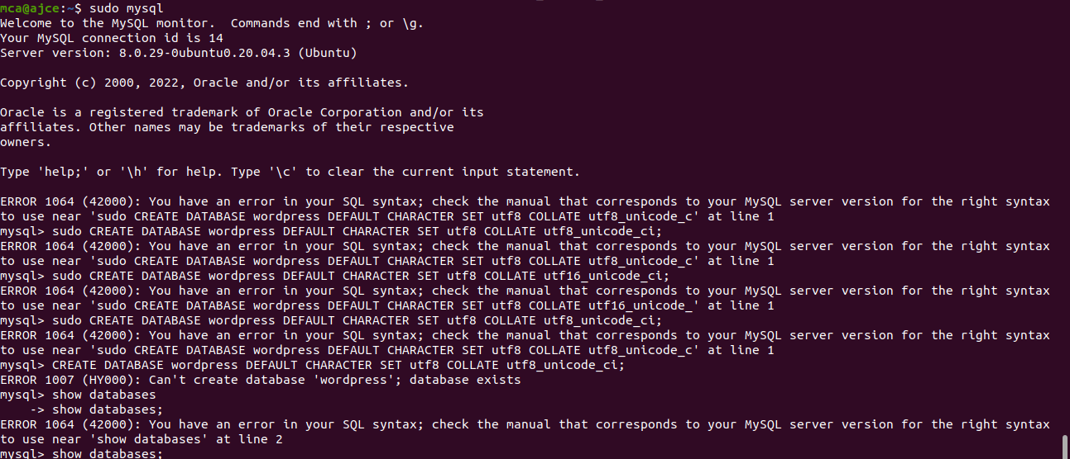

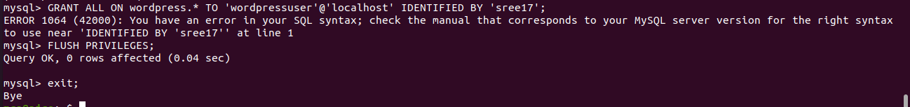

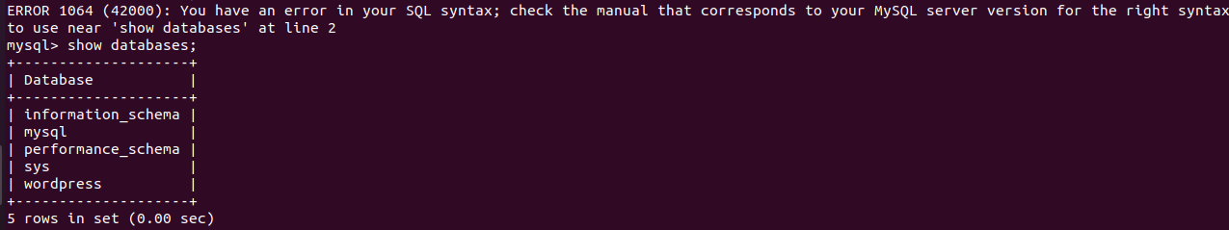

**Step 2** :

Go the /var/www/html/ directory and rename existing wp-config-sample.php to wpconfig.php. Also, make sure to remove the default Apache index page.

Syntax: sudo mv wp-config-sample.phpwp-config.php

sudorm -rf index.html

**Output:**

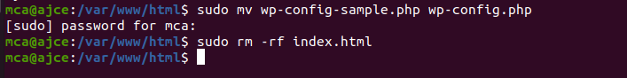

**Step 3** :Then update it with your database information under the MySQL settings section (refer to the highlighted boxes in the image below): This setting can be added after the database connection settings, or anywhere else in the file:.

Syntax:

define('DB_NAME', 'wordpress');

/** MySQL database username */

define('DB_USER', 'wordpressuser');

/** MySQL database password */

define('DB_PASSWORD', 'password');

. . .

define('FS_METHOD', 'direct');

**Output:**

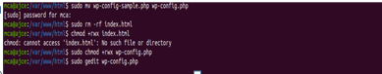

Save and close the file when you are finished.

**Step 4**: Restart the web server and mysql service

Syntax: $sudosystemctl restart apache2.service

$ sudosystemctl restart mysql.service

**Output:**

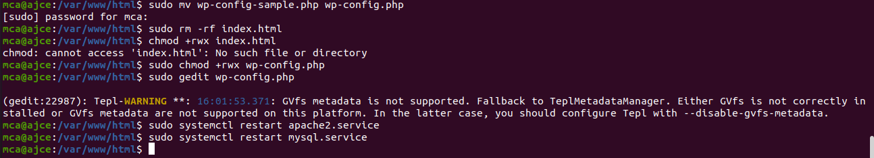**Step 5**: Completing the Installation Through the Web Interface

The server configuration is complete, you can complete the installation through the web interface.In your web browser, navigate to your server’s domain name or public IP address

**Output:**

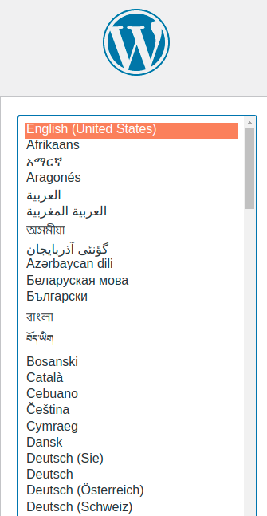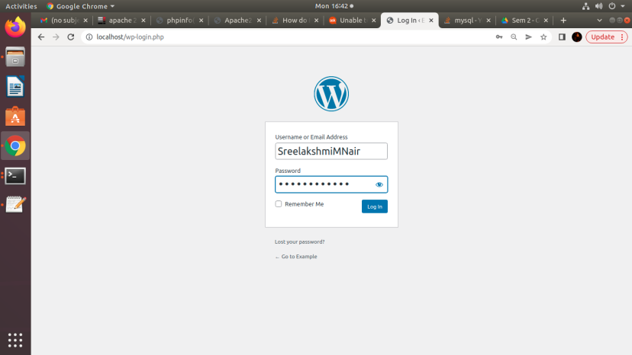



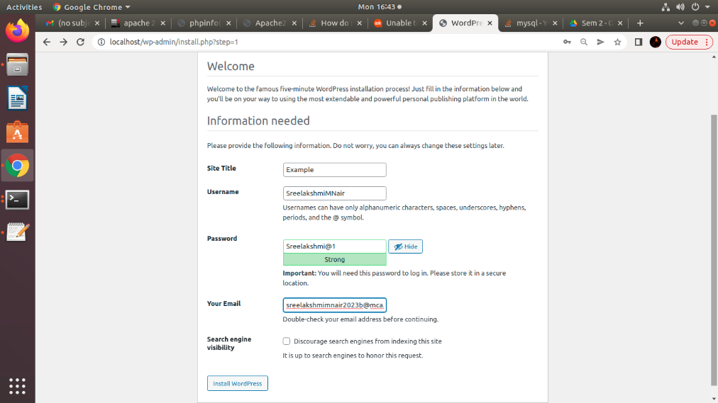

**Name: Neha Antony**

**Roll No:23**

**Batch: MCA -B**

**Date:06-06-2022**

**NETWORKING & SYSTEM ADMINISTRATION LAB**

**Experiment No.: 6**

**Aim**

Build and install software from source code, familiarity with make and cmake utilities expected.

**Procedure**

1. We can obtain information of a package and its dependencies using the apt command. Doing that for cmake:

**$ apt show cmake**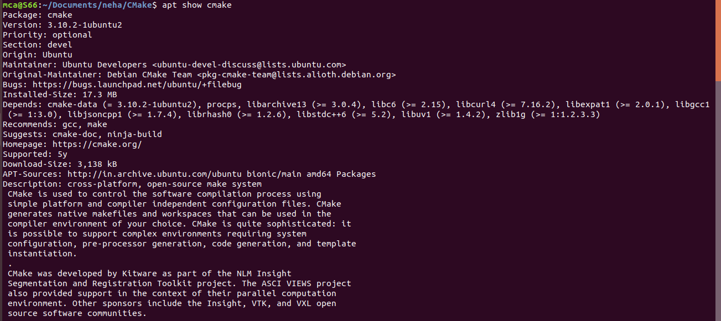

1. To install cmake , g++ and make using the apt command, type:

**$ sudo apt install cmake g++ make**

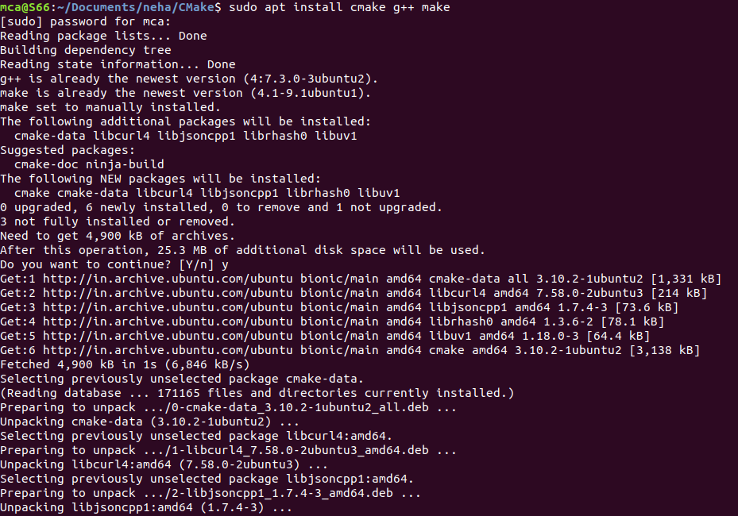

**A Sample CMake project**





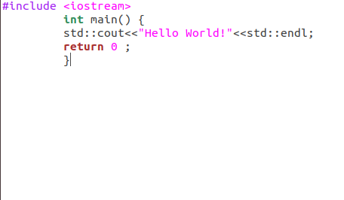

create configuration text file

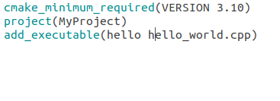

A directory to which CMake was executed is called “Built Directory”



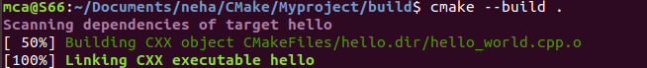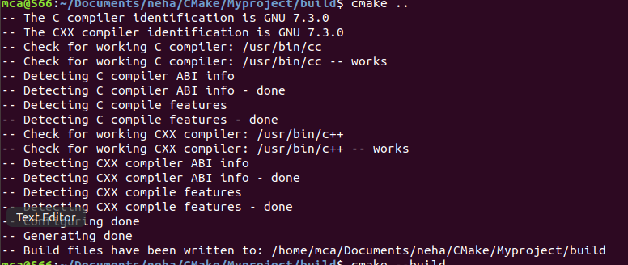



**Name: NEHA ANTONY**

**Roll No:23**

**Batch:MCA-B**

**Date:02-06-2022**

**NETWORKING & SYSTEM ADMINISTRATION LAB**

**Experiment No.: 7**

**Aim**

Introduction to command line tools for networking IPv4 networking, network commands: ping route traceroute, nslookup, ip.

**Procedure**

**Ipconfig**

"Ipconfig" often comes up as the most-used networking command on Windows. Not only is it useful for the information it provides, but you can combine it with a couple of switches to execute certain tasks.

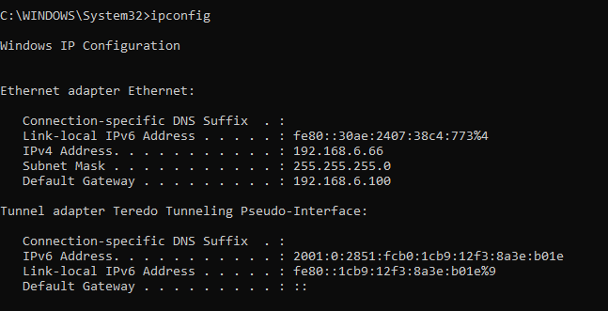

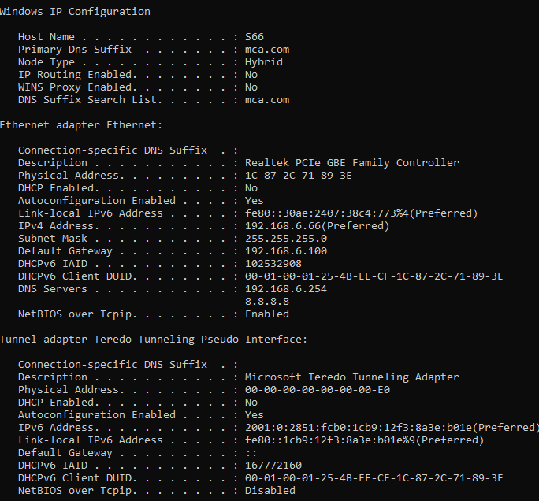

**Nslookup**

"Nslookup" stands for Name Server Lookup. It packs a lot of power, but most users won't need that power. For regular folks like you and me, its main use is finding out the IP address behind a certain domain name.

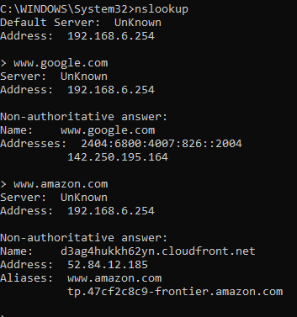

**Ping**

"Ping" is one of the most basic yet useful network commands to utilize in the command prompt application. It tells you whether your computer can reach some destination IP address or domain name, and if it can, how longit takes data to travel there and back again.

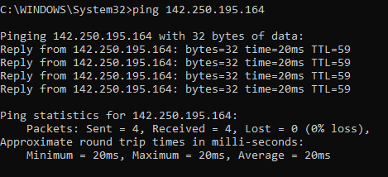

Tracert

"Tracert" stands for Trace Route. And much like "ping," it sends out a data packet as a way to troubleshoot any network issues you might have, but it instead tracks the route of the packet as it hops from server to server.

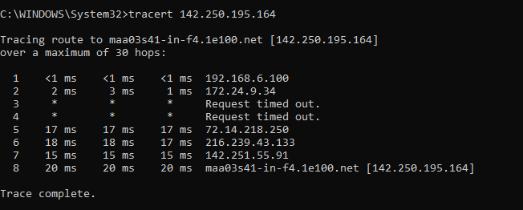

Netstat

"Netstat" is a tool for network statistics, diagnostics, and analysis. It's powerful and complex but can be simple enough if you ignore the advanced aspects that you don't need to know about (assuming you aren't managing a massive business or campus network, for example).

The -f option clears the routing tables of all gateway entries. If you use the -f option in conjunction with one of the commands, the tables are cleared before you run the command.

By default, routes are not preserved when you restart the system. Use the -p option with the add command to make a route persistent. Use the -p option with the print command to view the list of registered persistent routes.

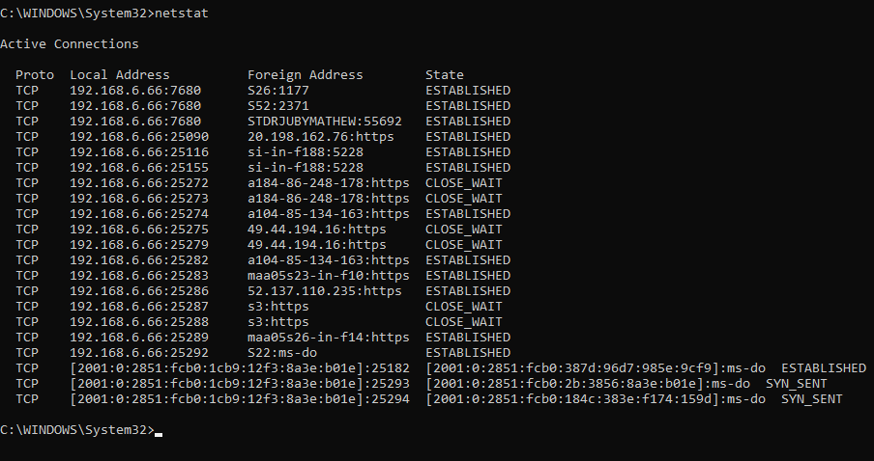

Route print

You can use the route command to view, add and delete routes on a Microsoft Windows NT server that runs Cisco ICM. You can use these options with the route command

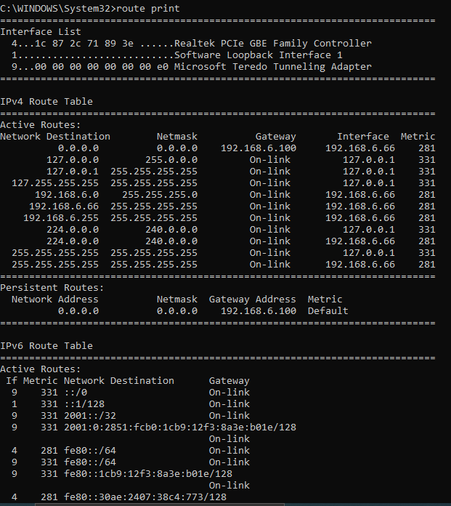

**Name: Neha Antony**

**Roll No:23**

**Batch:b**

**Date:23-05-2022**

**NETWORKING & SYSTEM ADMINISTRATION LAB**

**Experiment No.: 8**

**Aim**

Analyzing network packet stream using tcpdump and wireshark. Perform basic network service tests using nc.

**Procedure**

1. How to Install tcpdump in Linux

Many Linux distributions already shipped with the tcpdump tool, if in case you don’t have it on a system, you can install it using the command.

* $ sudo apt-get install tcpdump [On Debian, Ubuntu and Mint]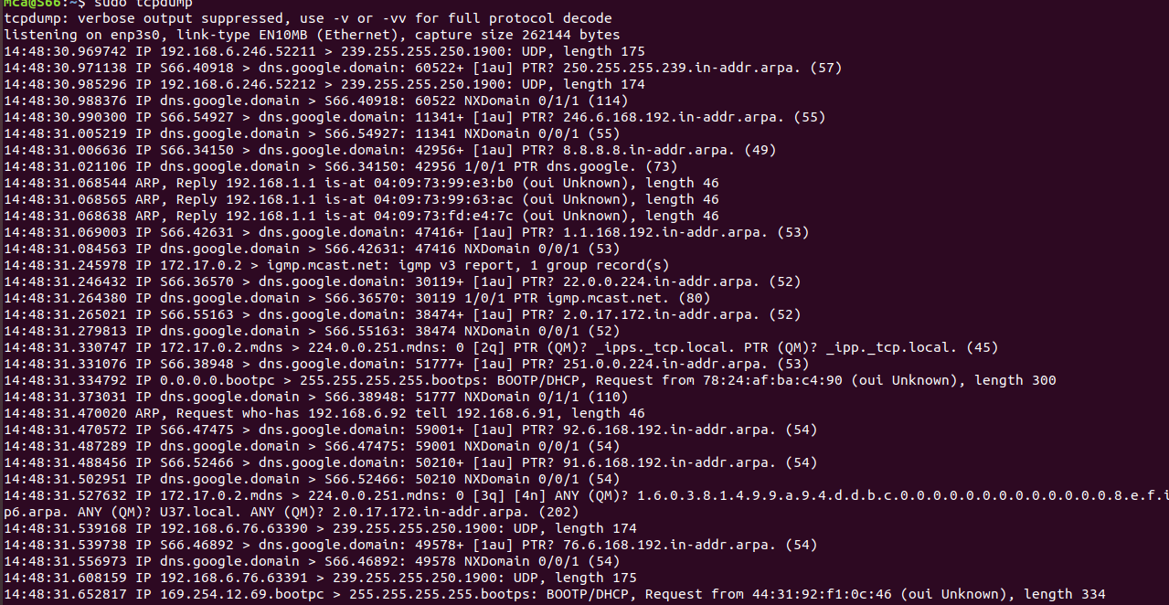

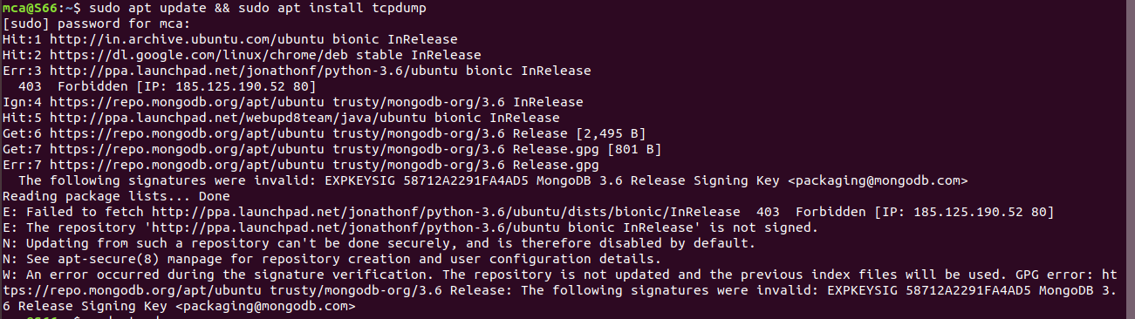

1. Display Available Interfaces

To list the number of available interfaces on the system, run the following command with -D option.

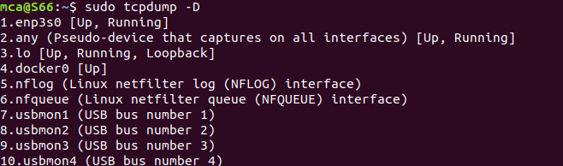

1. Capture Packets from Specific Interface

The command screen will scroll up until you interrupt and when we execute the tcpdump command it will captures from all the interfaces, however with -i switch only capture from the desired interface.

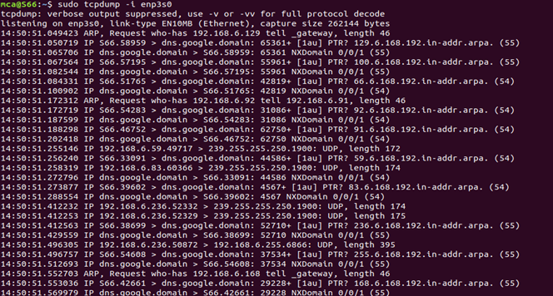

1. Capture Only N Number of Packets

When you run the tcpdump command it will capture all the packets for the specified interface, until you hit the cancel button. But using -c option, you can capture a specified number of packets.

# tcpdump –c 5 –i enp3s0

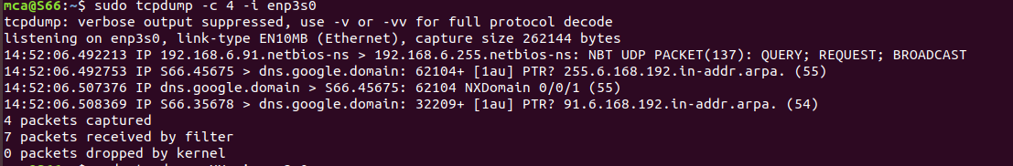

1. Display Captured Packets in HEX and ASCII

The following command with option -XX capture the data of each packet, including its link level header in HEX and ASCII format

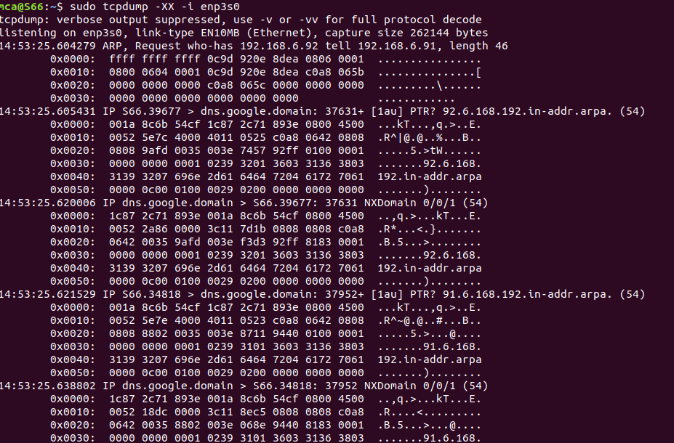

1. Capture and Save Packets in a File

As we said, that tcpdump has a feature to capture and save the file in a .pcap format, to do this just execute the command with -w option.

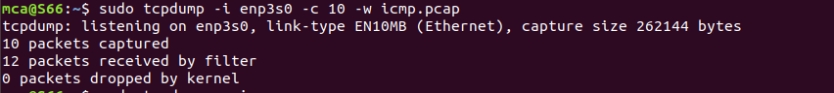

1. Capture Packet from Specific Port

Let’s say you want to capture packets for specific port 80, execute the below command by specifying port number 80 as shown below.

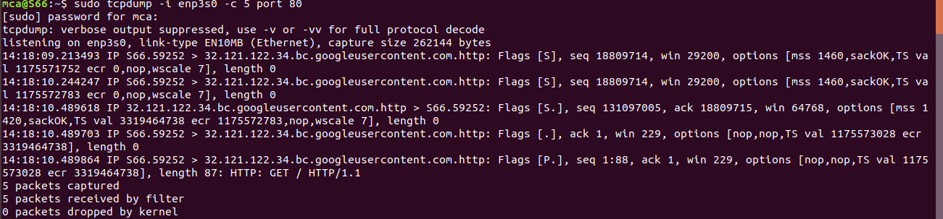

1. Read Captured Packets File

To read and analyze captured packet 0001.pcap file use the command with -r option.

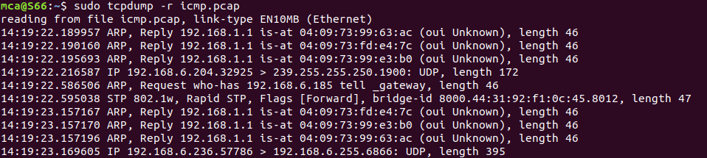

**wire shark**

Installing Wireshark on Ubuntu 20.04

The Wireshark utility is available on all major desktop platforms, i.e., Linux, Microsoft Windows, FreeBSD, MacOS, Solaris, and many more. Follow the steps below to install Wireshark on Ubuntu 20.04.

STEP1 : Update APT

First, as always, update and upgrade your APT through the following command.

Syntax:

**$ sudo apt update**

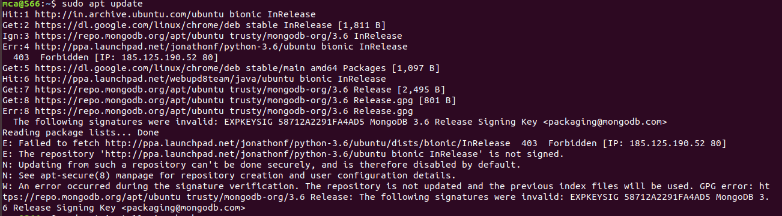

Step 2: Download and Install Wireshark

Now that Wireshark’s latest version has been added to the APT, you can download and install it with the following command.

syntax

**$ sudo apt install wireshark**

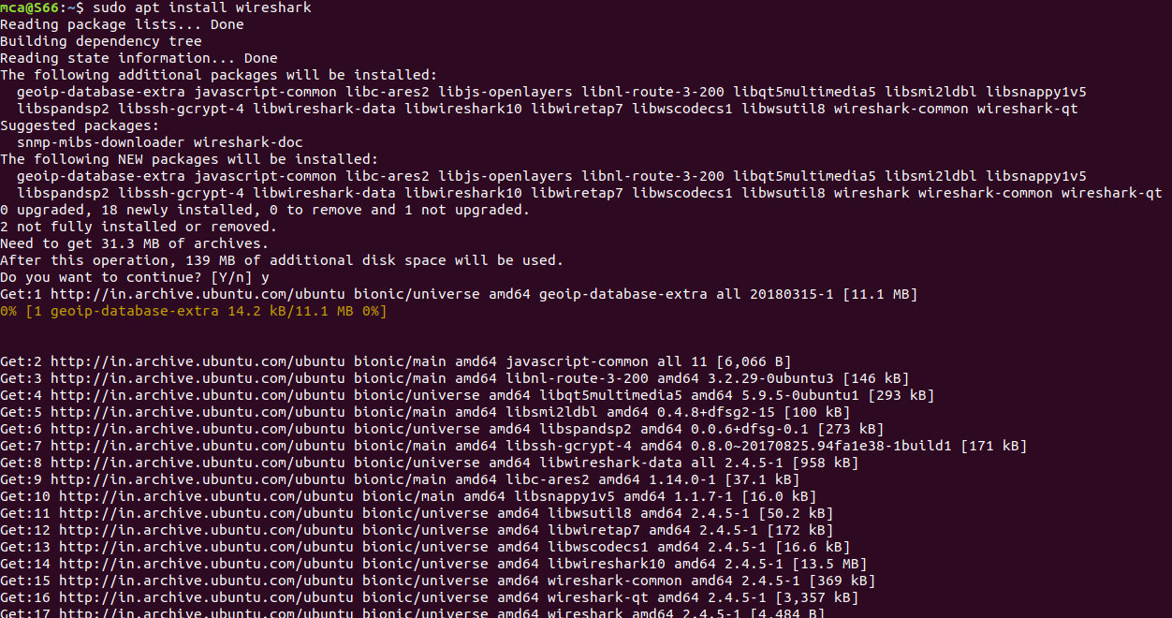

Step 3: Enable Root Privileges

When Wireshark installs on your system, you will be prompted by the following window. As Wireshark requires superuser/root privileges to operate, this option asks to enable or disable permissions for all every user on the system. Press the “Yes” button to allow other users, or press the “No” button to restrict other users from using Wireshark.

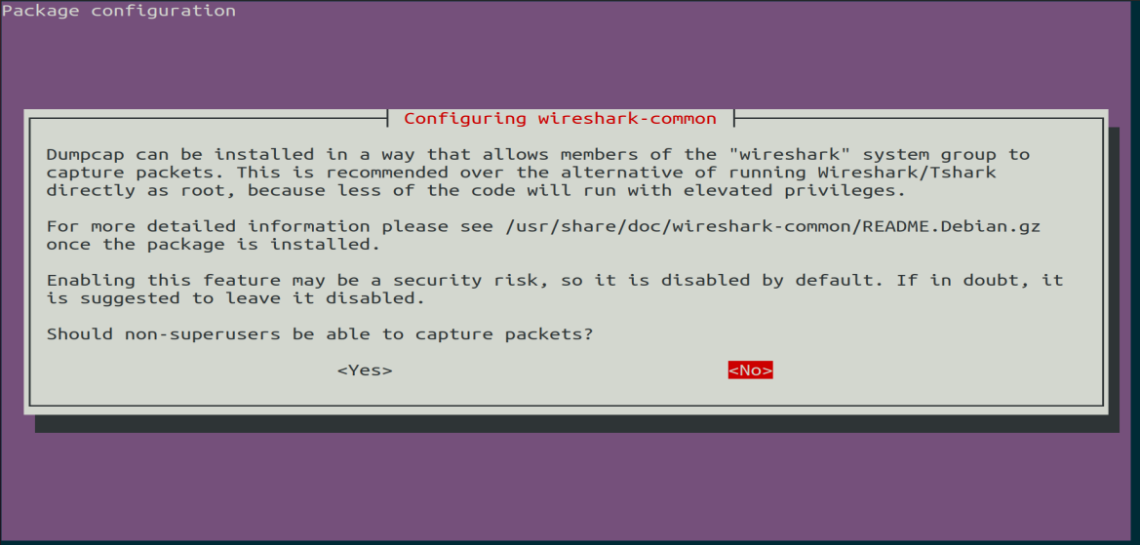

Step 4:

You must add a username to the Wireshark group so that this user can use Wireshark. To do this, execute the following command, adding your required username after “wireshark” in the command.

Syntax:

**$ sudo adduser $user wireshark**



Step 5: Launch Wireshark

In the terminal window, type the following command to start the Wireshark application.

Syntax:

**$ wireshark** 

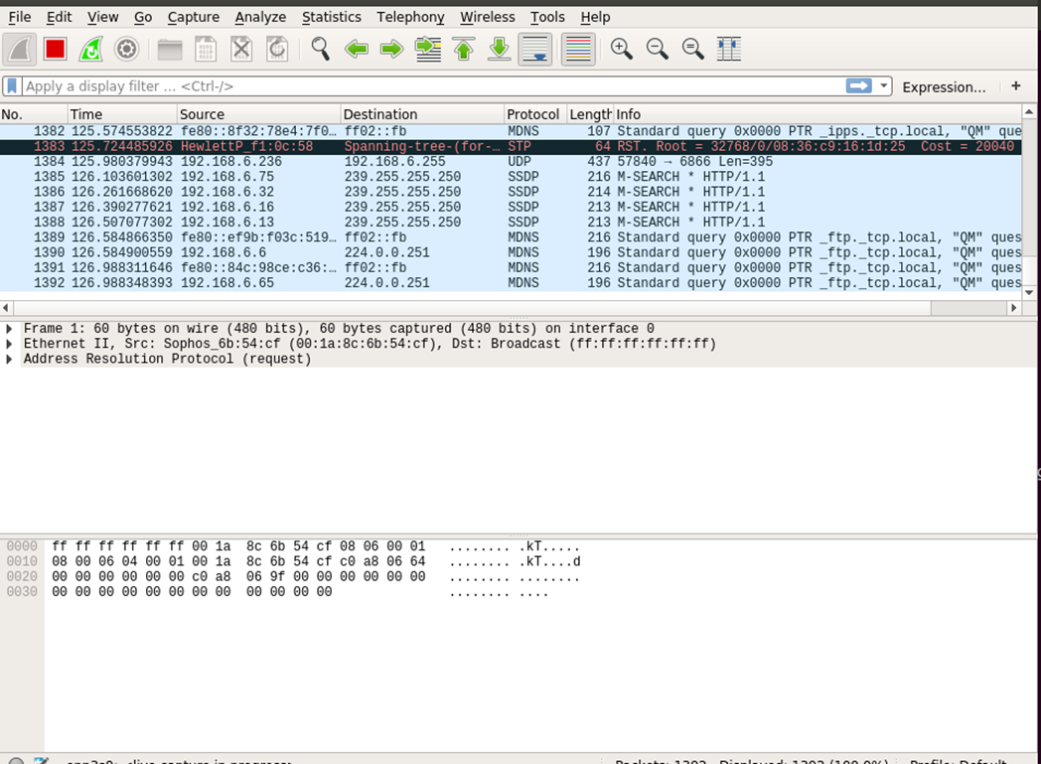

You can also open Wireshark through the Graphical User Interface (GUI) by opening the activities on the Ubuntu desktop, and in the search bar, type “Wireshark,” and click on the application result.



**netcat**

STEP1 : Update APT

First, as always, update and upgrade your APT through the following command.

Syntax:

**$ sudo apt update**

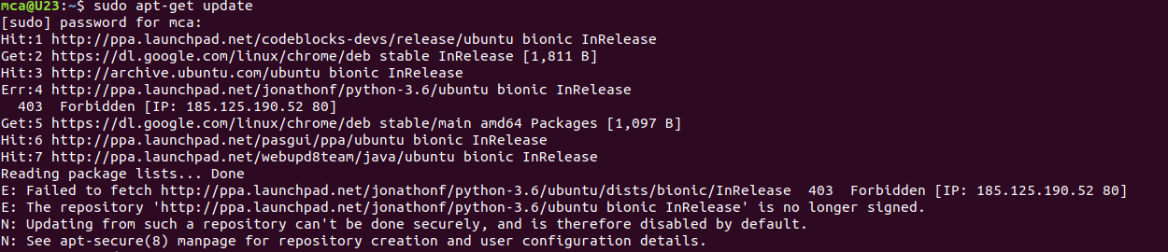

step 2: Install netcat

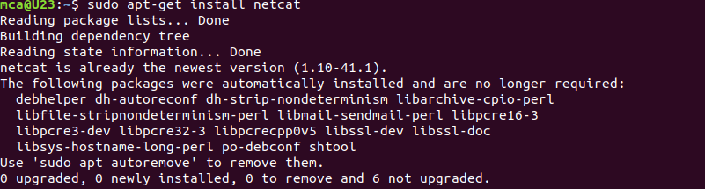

**working with netcat security tool**

To start listening on a port ,first open 2 window terminals

Terminal 1 for listening

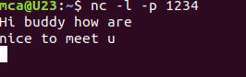

Terminal 2 sending requesting

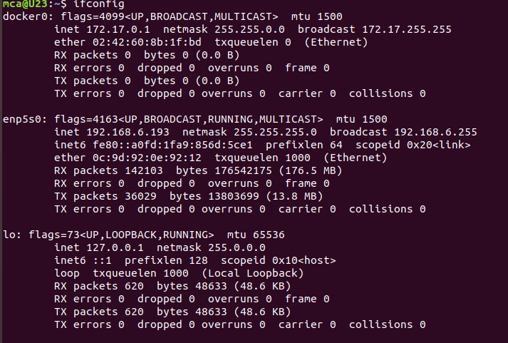

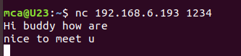

**Name: Neha Antony**

**Roll No:23**

**Batch:MCA-B**

**Date:07-06-2022**

**NETWORKING & SYSTEM ADMINISTRATION LAB**

**Experiment No.: 9**

**Aim**

Introduction to Hypervisors and VMs: KVM installation and commands

**Procedure**

**Step 1:** Update the repositories

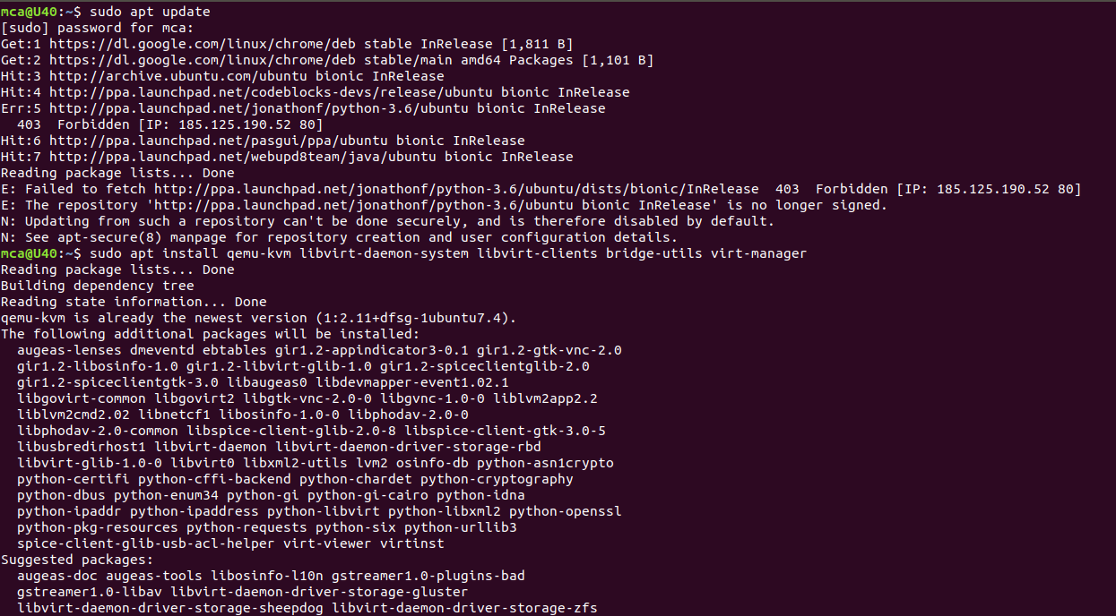

**Step 2:**Install essential KVM packages

 Install virt-manager, a tool for creating and managing VMs



**Step 3:** Start virt-manager with

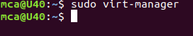

**Step 4:** In the first window, click the computer icon in the upper-left corner,

In the dialogue box that opens, select the option to install the VM using an ISO image. Then click **Forward**.

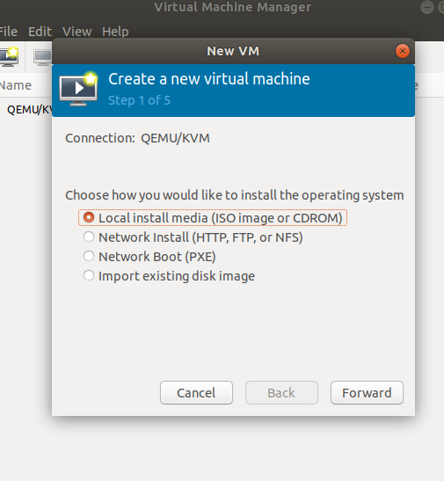

**Step 5:** Choose ISO,click Forward

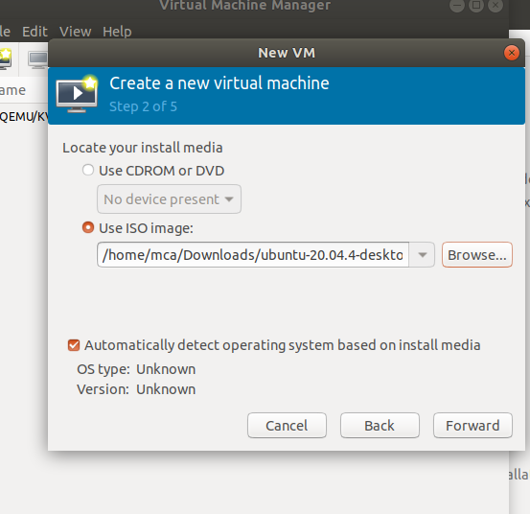

**Step 6:** Enter the amount of RAM and the number of CPUs you wish to allocate to the VM and proceed to the next step.

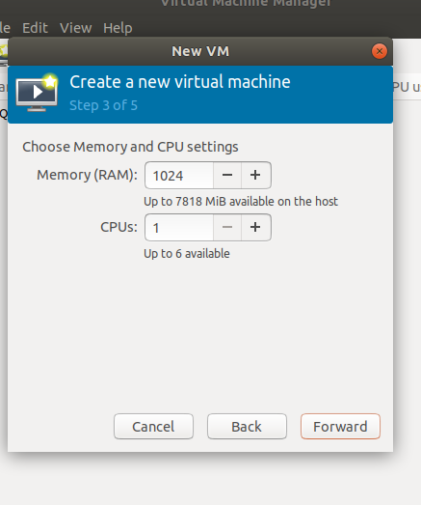

**Step 7:** Allocate hard disk space to the VM. Click **Forward** to go to the last step.

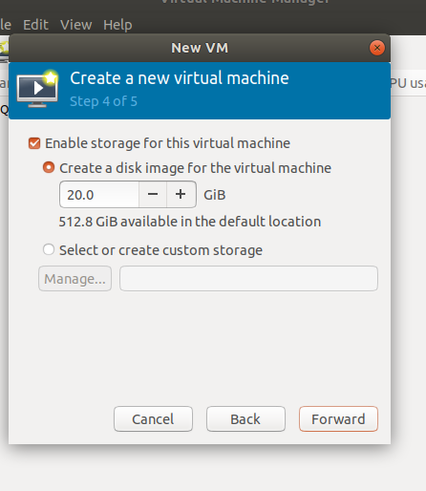

**Step 8:** Specify the name for your VM and click **Finish** to complete the setup.

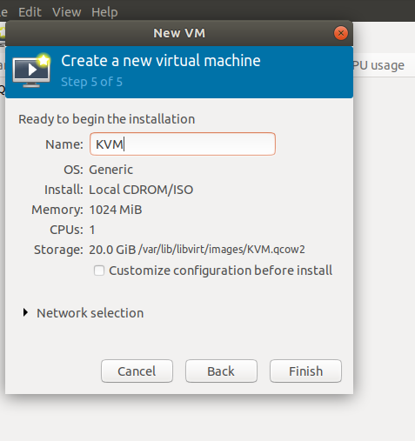

**Step 9: Select language**

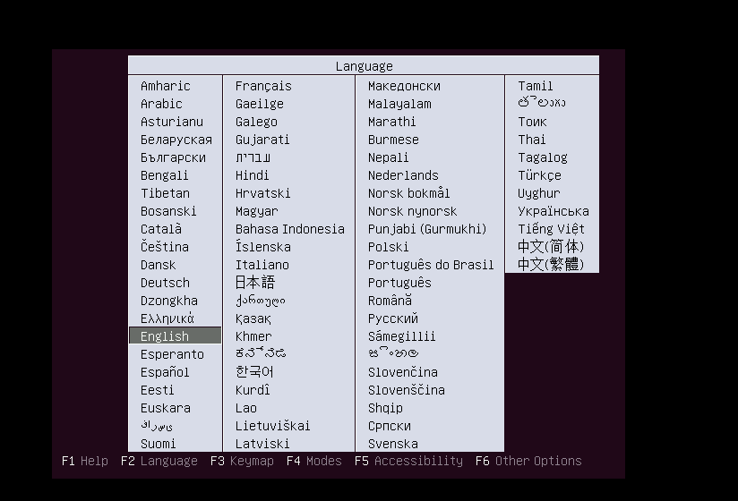

**Step 10:** The VM starts automatically, prompting you to start installing the OS that’s on the ISO file.

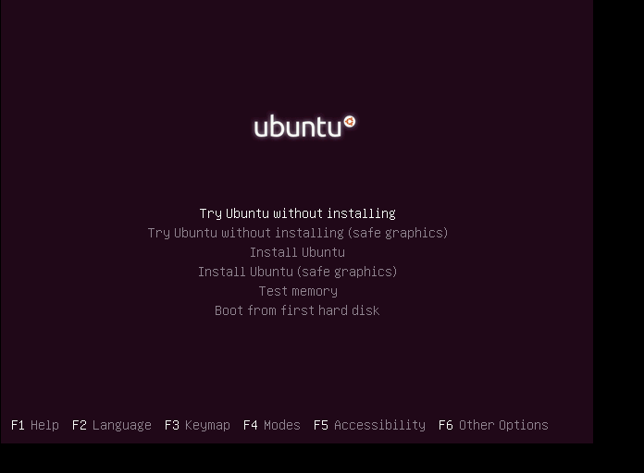

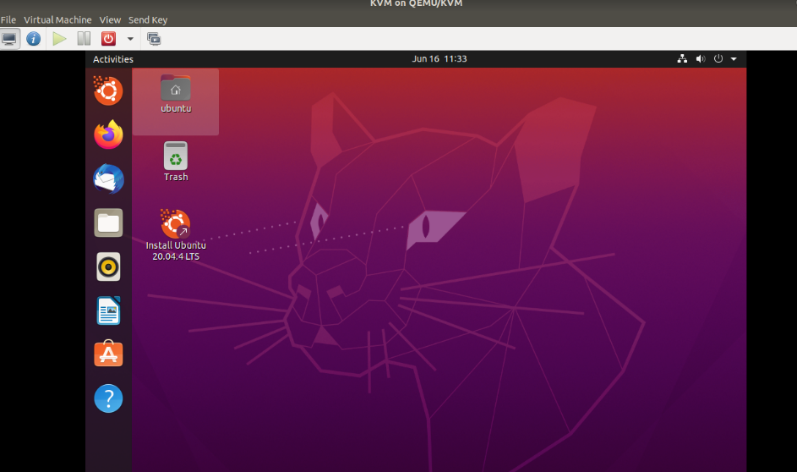

**Step 11: Check the state of KVM**

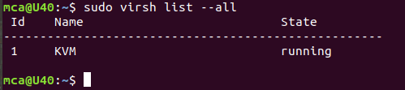

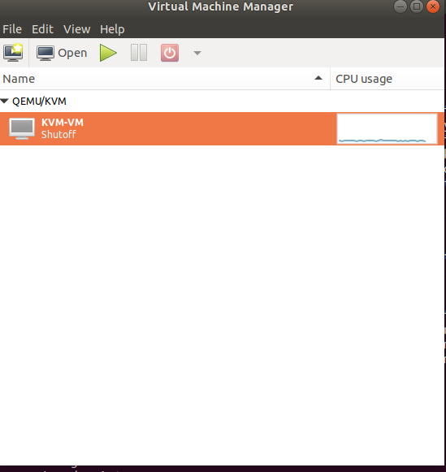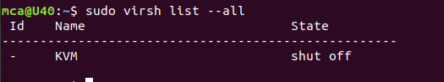

**Name: Neha Antony**

**Roll No:23**

**Batch:b**

**Date:23-05-2022**

**NETWORKING & SYSTEM ADMINISTRATION LAB**

**Experiment No.: 10**

**Aim**

Installation of Docker on Ubuntu

**Procedure**

step 1: Open the terminal on Ubuntu.

step 2: Remove any [Docker files](https://www.simplilearn.com/tutorials/docker-tutorial/what-is-dockerfile) that are running in the system, using the following command:

**$ sudo apt-get remove docker docker-engine docker.io**

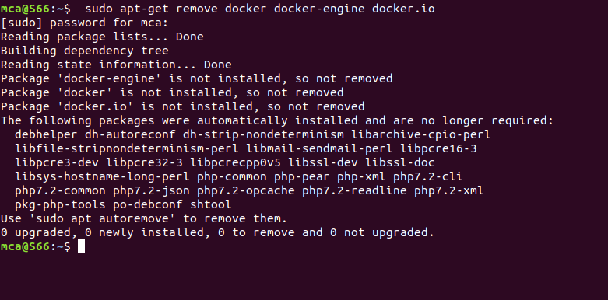

step 3: Check if the system is up-to-date using the following command:

**$ sudo apt-get update**

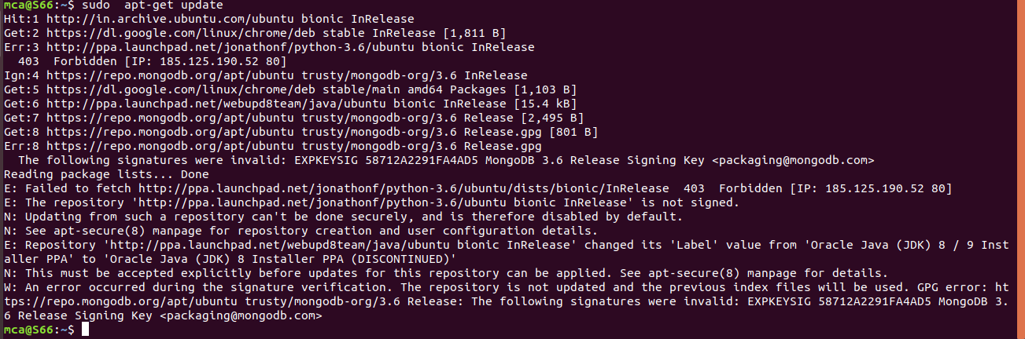

Step 4: Install Docker using the following command:

**$ sudo apt install docker.io**

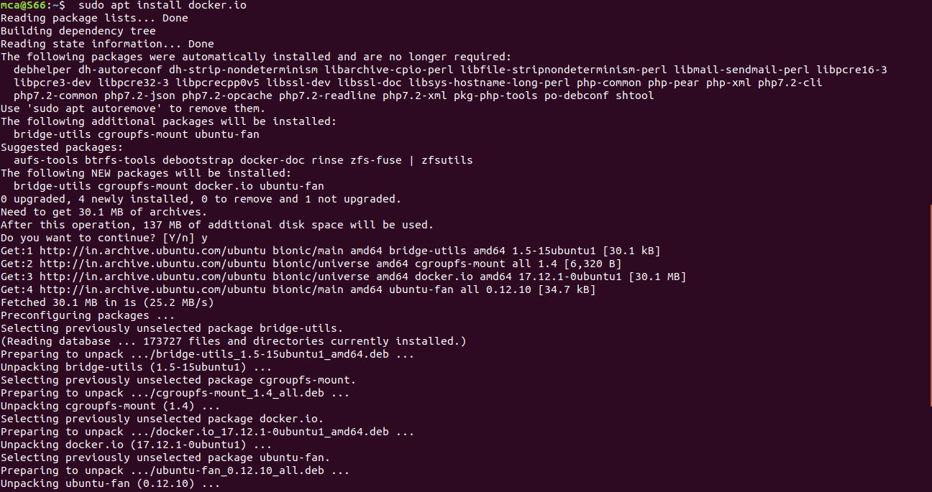

Step 5: Install all the dependency packages using the following command:

**$ sudo snap install docker**



Step 6: Before testing Docker, check the version installed using the following command:

**$ docker --version**



Step 7: Pull an image from the Docker hub using the following command:

**$ sudo docker run hello-world**

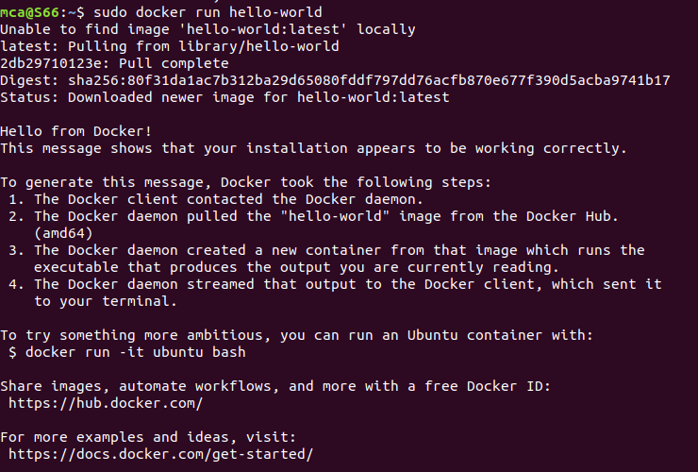

Step 8: Check if the docker image has been pulled and is present in your system using the following command:

**$ sudo docker images**



Step 9: To display all the containers pulled, use the following command:

**$ sudo docker ps -a**



Step 10: To check for containers in a running state, use the following command:

**$ sudo docker ps**



step 11: **sudo docker run -dit --name tecmint-web -p 8080:80 -v** /home/user/website/:/usr/local/apache2/htdocs/ httpd:2.4

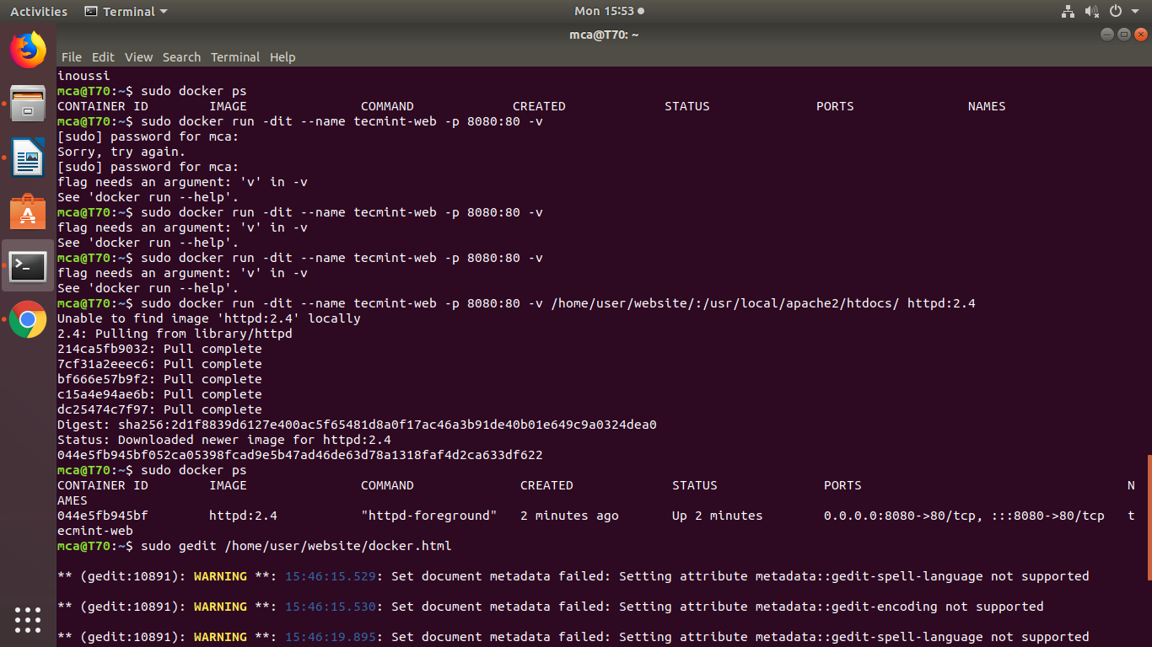

step 12: **$ sudo docker ps**



step 13 : **$ sudo gedit /home/user/website/docker.html**

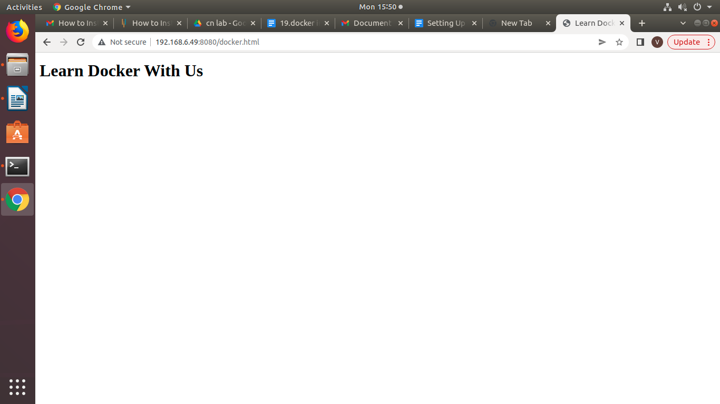

step 14 : **$ sudo docker stop tecmint-web**

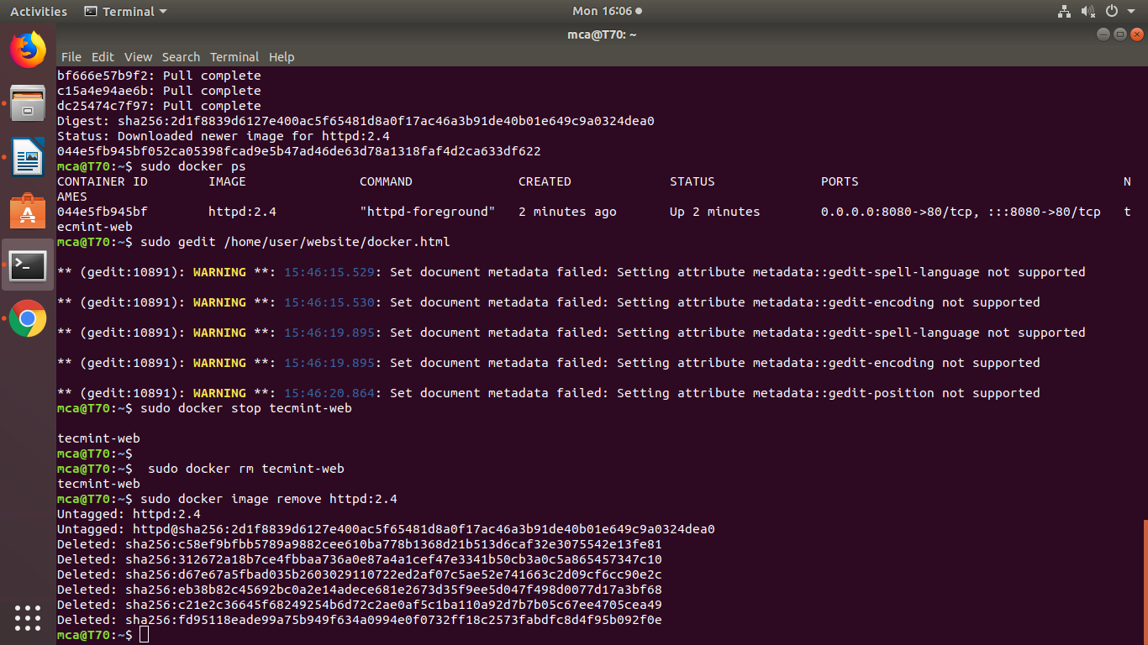

step 15:  **$ sudo docker rm tecmint-web**



step 16: **$ sudo docker image remove httpd:2.4**

